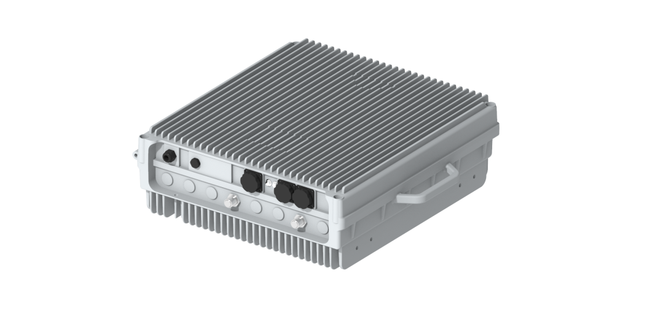

RU2460

HIGH POWER RRU

2T2R Digital Radios

40W (46dBm) Output Power

Passive Cooling

IP65 Outdoor Rated

The RU2460 from BTI Wireless is an advanced outdoor LTE product that operates in FDD mode. This RRU with sCELL-T4000 provide users with high-speed broadband wireless access to the Internet using 2x40W output power (2x2 MIMO with 40W output each channel). This RRU can operate in 5, 10 ,15or 20 MHz bandwidth.

|  |
| --- |
| **KEY FEATURES** |
| * Supports Band 2T2R * Up to 40W (46dBm) Output Power * Supports Cascading * Supports FDD * Supports External Alarm |

|  |  |
| --- | --- |
| **TECHNICAL SPECIFICATIONS** | |
| **SYSTEM** | |
| **Bandwidth per Channel (Downlink & Uplink)** | ≤ 20 MHz (Contiguous) |
| **Digital Bandwidth per Channel (Downlink & Uplink)** | 5/10/15/20 MHz |
| **Redundancy** | Cascading |

|  |  |  |  |  |
| --- | --- | --- | --- | --- |
| **SUPPORTED BANDS** | | | | |
| **Band Frequency** | **3GPP Band** | **Downlink Frequency** | **Uplink Frequency** | **Max Bandwidth** |
| 2100 MHz FDD | 1 | 2110MHz-2170MHz | 1920MHz-1980MHz | 20 |
| 1800 MHz FDD | 3 | 1805MHz-1880MHz | 1710Mz-1785MHz | 20 |
| 850 MHz FDD | 5 | 869MHz-894MHz | 829MHz-849MHz | 20 |
| 900 MHz FDD | 8 | 925MHz-960MHz | 880MHz-915MHz | 20 |
| 700 MHz FDD | 28 | 758MHz-803MHz | 703MHz-748MHz | 20 |

|  |  |
| --- | --- |
| **INTERFACES** | |
| **Antenna Interface (All bands)** | N Female |
| **Optical Connector Type** | SFP+, Standard LC |
| **Optical Transmission Rate** | 9.8304GB/s |
| **Optical Fiber Length** | 1.4 km/ 10 km/ 30 km  0.87mi / 6.21mi / 18.64mi |
| **Physical Alarms** | DB9, Female |
| **Maintenance Interface** | Ethernet RJ45 |

|  |  |
| --- | --- |
| **ELECTRICAL** | |
| **Complies with** | 3GPP TS36.106 | 3GPP TS25.106 |
| **EMC** | EN 301489-1 / -50, EN 55032 |
| **Safety** | EN 60950-1, EN 60950-22, EN 62368-1, EN 50385 |
| **Maximum Power Consumption** | 350W |

|  |  |
| --- | --- |
| **ENVIRONMENTAL** | |
| **Mean Time Between Failure (MTBF)** | > 100,000 hours |
| **Operating Temperature** | -40 °C ~ +55 °C | -40 °F ~ +131 °F |
| **Storage Temperature** | -40 °C ~ +70 °C | -40 °F ~ +158 °F |
| **Humidity** | 5% ~ 95% (Non-Condensing) |
| **Cooling** | Passive |
| **Installation** | Wall or Pole |
| **Ingress Protection Rating** | IP65 (Outdoor) |
| **Complies with** | EN 300019-1-1, EN 300019-1-2, EN 300019-1-4 |
| **Power Supply** | 176-264V AC, 45-65 Hz | 48VDC ± 20% |

|  |  |
| --- | --- |
| **MECHANICAL** | |
| **Size (Width x Height x Depth)** | 420*450*164.5 mm | 16.53*17.71*6.48 in |
| **Weight** | ≤22.0 kg | 48.50 lbs |

Contact Us

[www.btiwireless.com](http://www.btiwireless.com)

[sales@btiwireless.com](mailto:sales@btiwireless.com)