RU2430

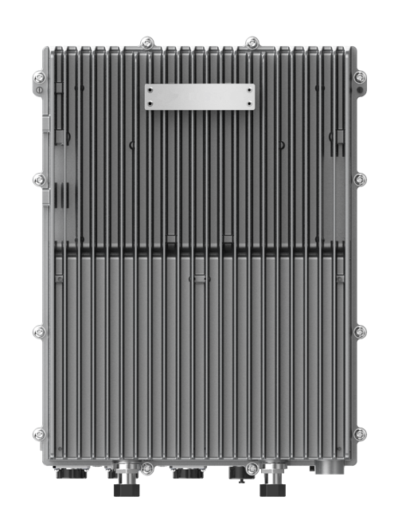HIGH POWER RRU

2T2R Digital Radios

20W (43dBm) Output Power

5G NR Complaint

IP65 Outdoor Rated

The RU2430 is a digital transport platform supporting cellular technologies on fiber optic cable using the CPRI protocol. The power amplifier technology adopts DPD (Digital Pre-Distortion), allowing for a significant improvement in power consumption compared with analogue technology. This platform is ideal for underground tunnels & outdoor coverage deployments of cellular services.

|  |
| --- |
| **KEY FEATURES** |
| * Supports Band 2T2R * Up to 20W (43dBm) Output Power * Supports Cascading * Supports TDD * Supports External Alarm |

|  |  |
| --- | --- |
| **TECHNICAL SPECIFICATIONS** | |
| **SYSTEM** | |
| **Bandwidth per Channel (Downlink & Uplink)** | ≤ 80 MHz (Contiguous) |
| **Digital Bandwidth per Channel (Downlink & Uplink)** | 3/5/10/20 MHz |
| **Redundancy** | Cascading |

|  |  |  |  |  |
| --- | --- | --- | --- | --- |
| **SUPPORTED BANDS** | | | | |
| **Band Frequency** | **3GPP Band** | **Downlink Frequency** | **Uplink Frequency** | **Max Bandwidth** |
| 2500 MHz TDD | 41 (LOWER/UPPER) | 2496-2576/2610-2690 | 2496-2576/2610-2690 | 80 |
| 2300 MHz TDD | 40 | 2300-2400 | 2300-2400 | 100 |
| 2600 MHz TDD | 38 | 2570-2620 | 2570-2620 | 50 |
| 2100 MHz FDD | 1 | 2110-2170 | 1920-1980 | 70 |
| 1800 MHz FDD | 3 | 1805-1880 | 1710-1785 | 75 |
| 900 MHz FDD | 8 | 925-960 | 880-915 | 35 |
| 2600 MHz FDD | 7 | 2620-2690 | 2500-2570 | 70 |

|  |  |
| --- | --- |
| **INTERFACES** | |
| **Antenna Interface (All bands)** | 4.3-10 Female |
| **Optical Connector Type** | SFP+, Standard LC |
| **Optical Transmission Rate** | 9.8304GB/s |
| **Optical Fiber Length** | 1.4 km/ 10 km/ 30 km  0.87mi / 6.21mi / 18.64mi |
| **Physical Alarms** | DB9, Female (4x in, 4x out) |
| **Maintenance Interface** | Ethernet RJ45 |

|  |  |
| --- | --- |
| **ELECTRICAL** | |
| **Complies with** | 3GPP TS36.106 | 3GPP TS25.106 |
| **EMC** | EN 301489-1 / -50, EN 55032 |
| **Safety** | EN 60950-1, EN 60950-22, EN 62368-1, EN 50385 |
| **Maximum Power Consumption** | 250W |

|  |  |
| --- | --- |
| **ENVIRONMENTAL** | |
| **Mean Time Between Failure (MTBF)** | > 100,000 hours |
| **Operating Temperature** | -40 °C ~ +55 °C | -40 °F ~ +131 °F |
| **Storage Temperature** | -40 °C ~ +70 °C | -40 °F ~ +158 °F |
| **Humidity** | 5% ~ 100% (Non-Condensing) |
| **Cooling** | Passive |
| **Installation** | Wall or Pole |
| **Ingress Protection Rating** | IP65 (Outdoor) |
| **Complies with** | EN 300019-1-1, EN 300019-1-2, EN 300019-1-4 |
| **Power Supply** | 100-240V AC, 50/60 Hz | 48VDC ± 20% |

|  |  |
| --- | --- |
| **MECHANICAL** | |
| **Size (Width x Height x Depth)** | 400 x 135 x 300 mm | 15.75 x 5.31 x 11.81 in |
| **Weight** | 18.0 kg | 39.68 lbs |

Contact Us

[www.btiwireless.com](http://www.btiwireless.com)

[sales@btiwireless.com](mailto:sales@btiwireless.com)