sCELL-T4000

## LTE Distributed Base Station

## LTE 2*2 MIMO/4*4 MIMO

## 5W / 20W / 40W RRU

## Max 3 LTE Carriers

## 256 Active-users per Cell

* GPS Clock synchronization

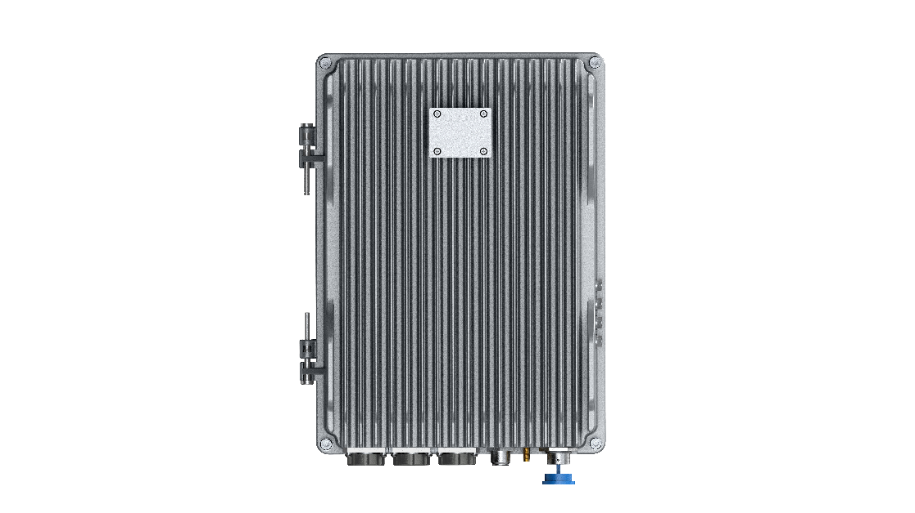

# Overview

The sCELL-T4000 from BTI Wireless mainly completes wireless access functions, including management of air interface, access control, mobility control, user resource allocation and other radio resource management and wireless service transmission functions. It consists of BaseBand Unit (BBU) T4000 and Remote Radio Unit (RRU).

|  |
| --- |
| **KEY FEATURES** |
| * Supports 3 x 20MHz LTE cells * Supports remote upgrade and management * Supports IPsec function to ensure data security * Supports 2 x 2 MIMO and 4 x 4 MIMO * Supports 256 active users per cell * MTBF > 100000 hours * Simple structure and easy installation * Supports GPS synchronization |

**Indoor and Outdoor BaseBand Unit (BBU)**



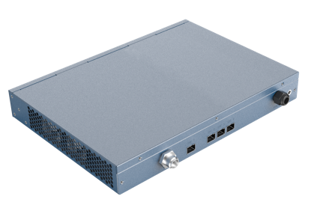

**sCELL-T4000-ID sCELL-T4000-OD**

|  |  |  |
| --- | --- | --- |
| **TECHNICAL SPECIFICATIONS** | | |
| **SYSTEM** | | |
| **3GPP** | Release 15 | |
| **LTE Technology** | TDD/FDD | |
| **Bandwidth** | 3/5/10/15/20 MHz | |
| **MIMO** | 2*2 MIMO/ 4*4 MIMO | |
| **Operational Capacity** | Each cell supports 256 active users and 512 RRCconnected users | |
| **VoLTE Performance** | Each cell supports up to 256 active VoLTE users | |
| **Throughput** | **TDD** | |
| **20 MHz@2TRX**  SA1: DL 80 Mbps  UL 17 Mbps  SA2: DL 110 Mbps  UL 10 Mbps | **20 MHz@4TRX**  SA1: DL 160 Mbps  UL 17 Mbps  SA2: DL 220 Mbps  UL 10 Mbps |
| **FDD** | |
| **20MHz@2TRX**  DL 125 Mbps  UL 46 Mbps | **20MHz@4TRX**  DL 242 Mbps  UL 46 Mbps |

|  |  |  |
| --- | --- | --- |
| **APPEARANCE** | **sCELL-T4000-ID** | **sCELL-T4000-OD** |
| **Installation Method** | Rack installation | Wall or Pole installation |
| **Size (L*W*H)** | 330 x 238 x 44 mm | 12.99 x 9.37 x 1.73 in | 322 x 245 x 136 mm | 12.68 x 9.65 x 5.35 in |
| **Weight** | 4 kg | 8.82 lbs | < 15 kg | 33.07 lbs |
| **Heat Dispersion** | Fan cooling | Natural cooling |

|  |  |  |
| --- | --- | --- |
| **ENVIRONMENTAL** | **sCELL-T4000-ID** | **sCELL-T4000-OD** |
| **Operating Temperature** | -10 °C ~ +45 °C | -14 °F ~ +113 °F | -40 °C ~ +55 °C | -40 °F ~ +131 °F |
| **Storage Temperature** | -40 °C ~ +70 °C | -40 °F ~ +158 °F | |
| **Humidity** | 15% ~ 85% | 5% ~ 98% |
| **Ingress Protection Degree** | IP20 | IP65 |

|  |  |
| --- | --- |
| **MONITORING AND CONTROL** | |
| **LMC**  **(Local Monitoring & Control)** | Internet, WEBOMT |
| **Remote Monitoring & Control** | TR069 protocol monitoring function |
| **OMT** | WEBOMT |

|  |  |  |
| --- | --- | --- |
| **ELECTRICAL** | **sCELL-T4000-ID** | **sCELL-T4000-OD** |
| **Power** | DC 48V standard power supply: DC 36V~60V | DC 48V standard power supply: DC 36V~60V |
| **Power Consumption** | 50W | 50W |
| **Reset Time** | ≤ 10 min | |
| **Backup Power** | No | |

|  |  |  |  |  |  |
| --- | --- | --- | --- | --- | --- |
| **INTERFACES** | | | | | |
| **No.** | **Definition** | **Number** | **Interface Standard** | **Interface ID** | **Function Description** |
| 1 | BBU board optical port | 3 | SFP | SFP1~4 | For RRU Cascading |
| 2 | BBU board optical port | 1 | SFP | SFP_ETH | Backhaul optical port |
| 3 | Ethernet port 1 | 1 | RJ45 | LAN | Local debugging port |
| 4 | Ethernet port 2 | 1 | RJ45 | WAN | Backhaul network port |
| 5 | GPS | 1 | SMA | GPS | Connect to GPS antenna |
| 6 | Indicator Light | 4 |  | PWR, RUN, 4G, GPS | Indicator light Indicates BBU status |
| 7 | USB | 1 | USB | USB | Connect USB disk |
| 8 | Power Supply | 1 |  | Power | AC/DC input |
| 9 | Switch | 1 | Rocker switch | SWITCH | Switching Functions |

RU2430

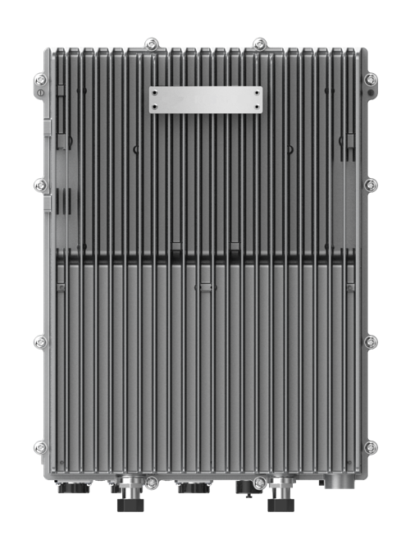HIGH POWER RRU

2T2R Digital Radios

20W (43dBm) Output Power

5G NR Complaint

IP65 Outdoor Rated

The RU2430 is a digital transport platform supporting cellular technologies on fiber optic cable using the CPRI protocol. The power amplifier technology adopts DPD (Digital Pre-Distortion), allowing for a significant improvement in power consumption compared with analogue technology. This platform is ideal for underground tunnels & outdoor coverage deployments of cellular services.

|  |
| --- |
| **KEY FEATURES** |
| * Supports Band 2T2R * Up to 20W (43dBm) Output Power * Supports Cascading * Supports TDD/FDD * Supports External Alarm |

|  |  |
| --- | --- |
| **TECHNICAL SPECIFICATIONS** | |
| **SYSTEM** | |
| **Bandwidth per Channel (Downlink & Uplink)** | ≤ 80 MHz (Contiguous) |
| **Digital Bandwidth per Channel (Downlink & Uplink)** | 3/5/10/20 MHz |
| **Redundancy** | Cascading |

|  |  |  |  |  |
| --- | --- | --- | --- | --- |
| **SUPPORTED BANDS** | | | | |
| **Band Frequency** | **3GPP Band** | **Downlink Frequency** | **Uplink Frequency** | **Max Bandwidth** |
| 2500 MHz TDD | 41 (LOWER/UPPER) | 2496-2576/2610-2690 | 2496-2576/2610-2690 | 80 |
| 2300 MHz TDD | 40 | 2300-2400 | 2300-2400 | 80 |
| 2600 MHz TDD | 38 | 2570-2620 | 2570-2620 | 50 |
| 2100 MHz FDD | 1 | 2110-2170 | 1920-1980 | 70 |
| 1800 MHz FDD | 3 | 1805-1880 | 1710-1785 | 75 |
| 900 MHz FDD | 8 | 925-960 | 880-915 | 35 |
| 2600 MHz FDD | 7 | 2620-2690 | 2500-2570 | 70 |

|  |  |
| --- | --- |
| **INTERFACES** | |
| **Antenna Interface (All bands)** | 4.3-10 Female |
| **Optical Connector Type** | SFP+, Standard LC |
| **Optical Transmission Rate** | 9.8304GB/s |
| **Optical Fiber Length** | 1.4 km/ 10 km/ 30 km  0.87mi / 6.21mi / 18.64mi |
| **Physical Alarms** | DB9, Female (4x in, 4x out) |
| **Maintenance Interface** | Ethernet RJ45 |

|  |  |
| --- | --- |
| **ELECTRICAL** | |
| **Complies with** | 3GPP TS36.106 | 3GPP TS25.106 |
| **EMC** | EN 301489-1 / -50,EN 55032 |
| **Safety** | EN 60950-1, EN 60950-22, EN 62368-1, EN 50385 |
| **Maximum Power Consumption** | 250W |

|  |  |
| --- | --- |
| **ENVIRONMENTAL** | |
| **Mean Time Between Failure (MTBF)** | > 100,000 hours |
| **Operating Temperature** | -40 °C ~ +55 °C | -40 °F ~ +131 °F |
| **Storage Temperature** | -40 °C ~ +70 °C | -40 °F ~ +158 °F |
| **Humidity** | 5% ~ 100% (Non-Condensing) |
| **Cooling** | Passive |
| **Installation** | Wall or Pole |
| **Ingress Protection Rating** | IP65 (Outdoor) |
| **Complies with** | EN 300019-1-1, EN 300019-1-2, EN 300019-1-4 |
| **Power Supply** | 100-240V AC, 50/60 Hz | 48VDC ± 20% |

|  |  |
| --- | --- |
| **MECHANICAL** | |
| **Size (Width x Height x Depth)** | 400 x 135 x 300 mm | 15.75 x 5.31 x 11.81 in |
| **Weight** | 18.0 kg | 39.68 lbs |

RU4370

MID POWER RRU

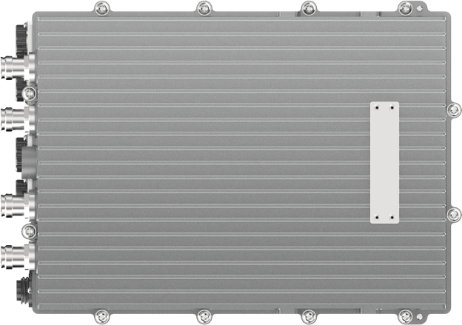

4T4R Digital Radios

5W (37dBm) Output Power

5GNR Compliant

IP67 Outdoor Rated

The RU4370 is a digital transport platform supporting cellular technologies on fiber optic cable using the CPRI protocol. The power amplifier technology adopts DPD (Digital Pre-Distortion), allowing for a significant improvement in power consumption compared with analogue technology. This platform is ideal for underground tunnels & outdoor coverage deployments of cellular services.

|  |
| --- |
| **KEY FEATURES** |
| * Supports 4T4R, 5G NR Compliant * Up to 5W (37dBm) Output Power and up to 100MHz IBW * Supports Cascading * Supports Sub-6GHz TDD/FDD and External Alarm |

|  |  |
| --- | --- |
| **TECHNICAL SPECIFICATIONS** | |
| **SYSTEM** | |
| **Bandwidth per Channel (Downlink & Uplink)** | ≤ 100 MHz (Contiguous) |
| **Digital Bandwidth per Channel (Downlink & Uplink)** | 3/5/10/20MHz for LTE  20/40/50/60/80/100 MHz for 5G |
| **Redundancy** | Cascading |

|  |  |  |  |  |
| --- | --- | --- | --- | --- |
| **SUPPORTED BANDS** | | | | |
| **Band Frequency** | **3GPP Band** | **Downlink Frequency** | **Uplink Frequency** | **Max Bandwidth** |
| 3600 MHz TDD | 48 | 3550-3700 | 3550-3700 | 100 |
| 3700 MHz TDD | 43 | 3600-3800 | 3600-3800 | 100 |
| 3500 MHz | N77/N78 | 3500-3800 | 3500-3800 | 100 |
| 3500 MHz | N77 | 3800-4100 | 3800-4100 | 100 |
| 3500 MHz | N77/N78 | 3400-3600 | 3400-3600 | 100 |
| 2600 MHz TDD | 41 | 2496-2690 | 2496-2690 | 100 |
| 2300 MHz TDD | 40 | 2300-2400 | 2300-2400 | 100 |
| 2600 MHz TDD | 38 | 2570-2620 | 2570-2620 | 50 |
| 2100 MHz FDD | 1 | 2110-2170 | 1920-1980 | 70 |
| 1800 MHz FDD | 3 | 1805-1880 | 1710-1785 | 75 |
| 2600 MHz FDD | 7 | 2620-2690 | 2500-2570 | 70 |
| *\* More bands will be supported in the roadmap* | | | | |

|  |  |
| --- | --- |
| **ELECTRICAL** | |
| **Complies with** | 3GPP TS36.106, 3GPP TS25.106 |
| **EMC** | EN 301489-1 / -50, EN 55032 |
| **Safety** | EN 60950-1, EN 60950-22, EN 62368-1, EN 50385 |
| **Maximum Power Consumption** | 140W |
| **Power Supply** | 48VDC ± 20% |

|  |  |
| --- | --- |
| **ENVIRONMENTAL** | |
| **Mean Time Between Failure (MTBF)** | > 100,000 hours |
| **Operating Temperature** | -40 °C ~ +55 °C | -40 °F ~ +131 °F |
| **Humidity** | 5% ~ 100% (Non-Condensing) |
| **Cooling** | Passive |
| **Installation** | Wall or Pole |
| **Ingress Protection Rating** | IP67 (Outdoor) |
| **Complies with** | EN 300019-1-1, EN 300019-1-2, EN 300019-1-4 |

|  |  |
| --- | --- |
| **MECHANICAL** | |
| **Size (Width x Height x Depth)** | 360 x 115 x 260 mm | 14.17 x 4.53 x 10.24 in |
| **Weight** | 12.0 kg | 26.46 lbs |

RU4460

EXTRA POWER RRU

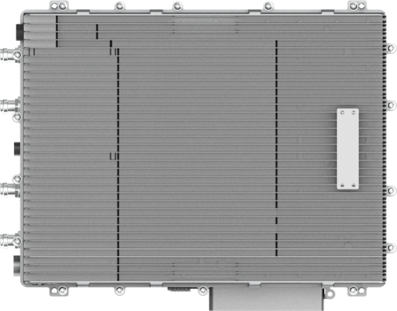

4T4R Digital Radios

40W (46dBm) Output Power

Passive Cooling

IP67 Outdoor Rated

The RU4460 is a digital transport platform supporting cellular technologies on fiber optic cable using the CPRI protocol. The power amplifier technology adopts DPD (Digital Pre-Distortion), allowing for a significant improvement in power consumption compared with analogue technology. This platform is ideal for underground tunnels & outdoor coverage deployments of cellular services.

|  |
| --- |
| **KEY FEATURES** |
| * Supports 2T2R & 4T4R * Up to 40W (46dBm) Output Power * Supports Cascading * Supports Sub-6GHz TDD/FDD and External Alarm |

|  |  |
| --- | --- |
| **TECHNICAL SPECIFICATIONS** | |
| **SYSTEM** | |
| **Bandwidth per Channel (Downlink & Uplink)** | ≤ 100 MHz (Contiguous) |
| **Digital Bandwidth per Channel (Downlink & Uplink)** | 3/5/10/20 MHz |
| **Redundancy** | Cascading |

|  |  |  |  |  |
| --- | --- | --- | --- | --- |
| **SUPPORTED BANDS** | | | | |
| **Band Frequency** | **3GPP Band** | **Downlink Frequency** | **Uplink Frequency** | **Max Bandwidth** |
| 2300MHz TDD | 40 | 2300-2400 | 2300-2400 | 100 |
| 2500MHz TDD | 41 | 2496-2690 | 2496-2690 | 100 |
| 2600MHz TDD | 38 | 2570-2620 | 2570-2620 | 50 |
| 3500MHz TDD | 42 | 3400-3600 | 3400-3600 | 100 |
| 3600MHz TDD | 43 | 3600-3800 | 3600-3800 | 100 |
| 2100 MHz FDD | 1 | 2110-2170 | 1920-1980 | 70 |
| 1800 MHz FDD | 3 | 1805-1880 | 1710-1785 | 75 |
| 2600 MHz FDD | 7 | 2620-2690 | 2500-2570 | 70 |
| *\* More bands will be supported in the roadmap* | | | | |

|  |  |
| --- | --- |
| **INTERFACES** | |
| **Antenna Interface (All bands)** | 4.3-10 Female |
| **Optical Connector Type** | SFP+, Standard LC |
| **Optical Transmission Rate** | 9.8304GB/s |
| **Optical Fiber Length** | 1.4km / 10km / 30km  0.87mi / 6.21mi / 18.64mi |
| **Dry Contact** | 2 Inputs & 2 Outputs, NO and NC Mode |
| **Maintenance Interface** | Ethernet RJ45 |

|  |  |
| --- | --- |
| **ELECTRICAL** | |
| **Complies with** | 3GPP TS36.106 | 3GPP TS25.106 |
| **EMC** | EN 301489-1 / -50, EN 55032 |
| **Safety** | EN 60950-1, EN 60950-22, EN 62368-1, EN 50385 |
| **Maximum Power Consumption** | 700W |
| **Power Supply** | 48VDC ± 20% |

|  |  |
| --- | --- |
| **ENVIRONMENTAL** | |
| **Mean Time Between Failure (MTBF)** | > 100,000 hours |
| **Operating Temperature** | -40 °C ~ +55 °C | -40 °F ~ +131 °F |
| **Humidity** | 5% to 100% (Non-Condensing) |
| **Cooling** | Passive |
| **Installation** | Wall or Pole |
| **Ingress Protection Rating** | IP67 (Outdoor) |
| **Complies with** | EN 300019-1-1, EN 300019-1-2, EN 300019-1-4 |

|  |  |
| --- | --- |
| **MECHANICAL** | |
| **Size (Width x Height x Depth)** | 445 x 135 x 415 mm | 17.52 x 5.31 x 16.34 in |
| **Weight** | 27.9 kg | 61.5 lbs |

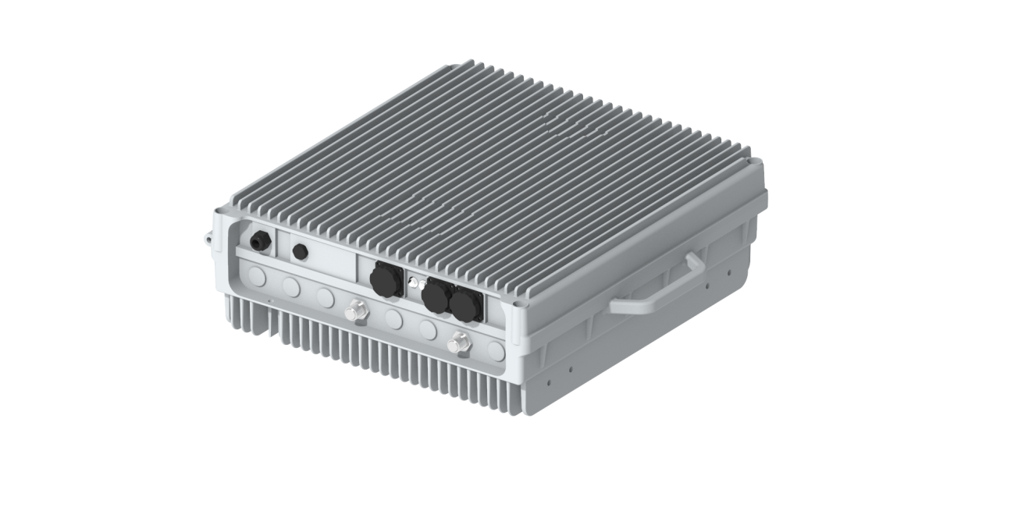

RU2460

HIGH POWER RRU

2T2R Digital Radios

40W (46dBm) Output Power

Passive Cooling

IP65 Outdoor Rated

The RU2460 from BTI Wireless is an advanced outdoor LTE product that operates in FDD mode. This RRU with sCELL-T4000 provide users with high-speed broadband wireless access to the Internet using 2x40W output power (2x2 MIMO with 40W output each channel). This RRU can operate in 5, 10 ,15or 20 MHz bandwidth.

|  |
| --- |
| **KEY FEATURES** |
| * Supports Band 2T2R * Up to 40W (46dBm) Output Power * Supports Cascading * Supports FDD * Supports External Alarm |

|  |  |
| --- | --- |
| **TECHNICAL SPECIFICATIONS** | |
| **SYSTEM** | |
| **Bandwidth per Channel (Downlink & Uplink)** | ≤ 20 MHz (Contiguous) |
| **Digital Bandwidth per Channel (Downlink & Uplink)** | 5/10/15/20 MHz |
| **Redundancy** | Cascading |

|  |  |  |  |  |
| --- | --- | --- | --- | --- |
| **SUPPORTED BANDS** | | | | |
| **Band Frequency** | **3GPP Band** | **Downlink Frequency** | **Uplink Frequency** | **Max Bandwidth** |
| 2100 MHz FDD | 1 | 2110MHz-2170MHz | 1920MHz-1980MHz | 20 |
| 1800 MHz FDD | 3 | 1805MHz-1880MHz | 1710Mz-1785MHz | 20 |
| 850 MHz FDD | 5 | 869MHz-894MHz | 829MHz-849MHz | 20 |
| 900 MHz FDD | 8 | 925MHz-960MHz | 880MHz-915MHz | 20 |
| 700 MHz FDD | 28 | 758MHz-803MHz | 703MHz-748MHz | 20 |

|  |  |
| --- | --- |
| **INTERFACES** | |
| **Antenna Interface (All bands)** | N Female |
| **Optical Connector Type** | SFP+, Standard LC |
| **Optical Transmission Rate** | 9.8304GB/s |
| **Optical Fiber Length** | 1.4 km/ 10 km/ 30 km  0.87mi / 6.21mi / 18.64mi |
| **Physical Alarms** | DB9, Female |
| **Maintenance Interface** | Ethernet RJ45 |

|  |  |
| --- | --- |
| **ELECTRICAL** | |
| **Complies with** | 3GPP TS36.106 | 3GPP TS25.106 |
| **EMC** | EN 301489-1 / -50, EN 55032 |
| **Safety** | EN 60950-1, EN 60950-22, EN 62368-1, EN 50385 |
| **Maximum Power Consumption** | 350W |

|  |  |
| --- | --- |
| **ENVIRONMENTAL** | |
| **Mean Time Between Failure (MTBF)** | > 100,000 hours |
| **Operating Temperature** | -40 °C ~ +55 °C | -40 °F ~ +131 °F |
| **Storage Temperature** | -40 °C ~ +70 °C | -40 °F ~ +158 °F |
| **Humidity** | 5% ~ 95% (Non-Condensing) |
| **Cooling** | Passive |
| **Installation** | Wall or Pole |
| **Ingress Protection Rating** | IP65 (Outdoor) |
| **Complies with** | EN 300019-1-1, EN 300019-1-2, EN 300019-1-4 |
| **Power Supply** | 176-264V AC, 45-65 Hz | 48VDC ± 20% |

|  |  |
| --- | --- |
| **MECHANICAL** | |
| **Size (Width x Height x Depth)** | 420 x 450 x 164.5 mm | 16.53 x 17.71 x 6.48 in |
| **Weight** | ≤22.0 kg | 48.50 lbs |

Contact Us

[www.btiwireless.com](http://www.btiwireless.com)

[sales@btiwireless.com](mailto:sales@btiwireless.com)