nCELL-RU4370

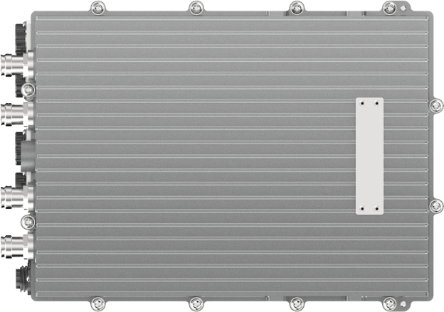5G Remote Radio Unit

4T4R

5W (37±2dBm)

5GNR

IBW 100 MHz

The nCELL-RU4370 from BTI WIRELESS is a radio frequency unit (RRU) for 5G NR outdoor base stations. It forms a complete 5G base station together with the baseband unit (BBU), which is used in mobile communication cell cellular networking scenarios.

The platform supports fiber optic cable cellular technology with eCPRI protocol. The Power amplifier technology uses DPD (digital pre-distortion) technology, compared with analog technology, power consumption has been significantly improved. The platform is ideal for underground tunnel and outdoor overlay deployments for cellular services.

|  |
| --- |
| **APPEARANCE** |
|  |

|  |  |
| --- | --- |
| **TECHNICAL SPECIFICATIONS** | |
| **Technology** | 5G NR |
| **Standard** | 3GPP R16 |
| **Size** | 360 x 115 x 260 mm | 14.17 x 4.53 x 10.24 in |
| **Weight** | < 12.0 kg | 26.46 lbs |
| **MIMO** | 4 x 4 MIMO |
| **Number of Transmit and Receive Channels** | 4T4R |
| **Output Power** | 4 x 5W (37±2dBm) |
| **Working Bandwidth** | N38:2570MHz-2620 MHz  N40:2300MHz-2400MHz  N41:2496MHz-2690MHz  N77/N78:3400MHz-3600MHz  N48:3550MHz-3700MHz  N77/N78: 3500MHz-3800MHz  N77:3800MHz-4100MHz  N77:4000MHz-4200MHz  Band Customization |
| **Channel Bandwidth** | 10MHz/20MHz/40MHz/50MHz/60MHz/80MHz/100MHz |
| **Sensitivity** | -98dBm/channel |
| **Power Supply** | 48V DC, ±20% |
| **Power Consumption** | < 150W |
| **MTBF** | > 100,000 hours |

|  |  |
| --- | --- |
| **IR INTERFACE INDEX** | |
| **Interface** | Supports eCPRI interface (option 7-2) |
| **Interfaces to Antenna** | 4.3-10 Female |
| **IR Interface Rate** | 13.125 Gbit/s |
| **VSWR** | 1.5 |
| **AISG** | AISG 2.0 |
| **ACLR** | ETSI TS 136.104 |
| **Operating Band Unwanted Emissions** | ETSI TS 136.104 |
| **TX Spurious Emissions** | ETSI TS 136.104 |
| **External Alarm** | 2 x Inputs & 2 x Output |
| **Maintenance Interface** | Ethernet RJ45 |

|  |  |
| --- | --- |
| **ENVIRONMENTAL SPECIFICATIONS** | |
| **Working Temperature** | -40 °C ~ +55 °C | -40 °F ~ +131 °F |
| **Cooling Method** | Natural |
| **Humidity** | 5%~100% |
| **Installation** | Wall-mounted or Pole-mounted |
| **Protect Level** | IP67 |
| **Environmental** | IEC60529 IP67 |
| **Safety** | EN 62368-1 |
| **Electromagnetic Compliance** | EN 301 908-1, EN 301 908-24, ETSI EN 301489-1, EN 301 489-50, EN 55032, EN 61000-3-3, EN 61000-3-2, EN 55035 |

|  |
| --- |
| **INTERFACE** |
| 1  2  4  3    11  8  9  10  5  6  7 |

|  |  |  |  |
| --- | --- | --- | --- |
| **INTERFACE SPECIFICATIONS** | | | |
| 1 | Duplex DL/UL RF Port 1 | 2 | Duplex DL/UL RF Port 2 |
| 3 | Duplex DL/UL RF Port 3 | 4 | Duplex DL/UL RF Port 4 |
| 5 | OP Port for DU Connection | 6 | OP Port for Cascade |
| 7 | LED Indicator of OP & System | 8 | Maintenance Interface |
| 9 | External Alarm Port | 10 | AISG Port |
| 11 | Power Socket Interface |  |  |

Contact Us Today

[www.btiwireless.com](http://www.btiwireless.com)

[sales@btiwireless.com](mailto:sales@btiwireless.com)