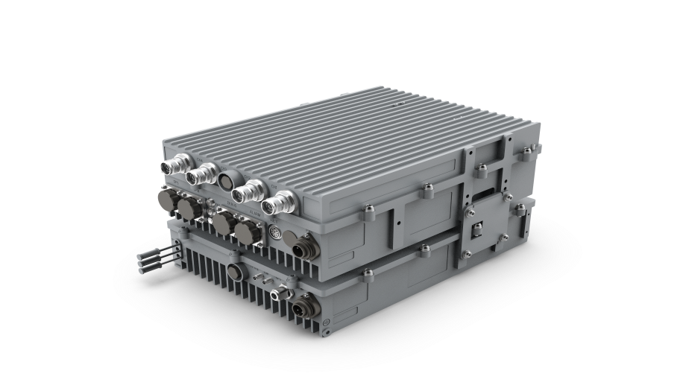nCELL-M4370

5G Integrated Base Station

5W

4T4R

All-in-one Design

Clock Synchronization

The nCELL-M4370 from BTI WIRELESS is based on advanced multi-core ARM and FPGA solutions and adopts an integrated design method of 5G BBU and RRU. Based on a completely independent research and development protocol stack and system software, it realizes a complete 5G NR wireless access, which can quickly provide users with a reliable 5G wireless coverage network.

The nCELL-M4370 has the advantages of low power consumption, small size, convenient construction, etc., and is suitable for applications in many 5G vertical industries.

|  |  |
| --- | --- |
| **SYSTEM FUNCTIONS** | |
| **Standard** | 3GPP R16 |
| **Number of Cells** | 1 x 4T4R or 2 x 2T2R |
| **Cell Capacity** | 400 RRC users per cell |
| **Cell Throughput** | DL 1.5 Gbps, UL 260 Mbps (DDDSU)  DL 658 Mbps, UL 669 Mbps (DSUUU) |
| **Operating Frequency Band** | N38:2570-2620 MHz；  N40:2300-2400MHz；  N41:2496-2690MHz；  N48(CBRS): 3550-3700MHz;  N77/N78: 3500-3800MHz;  N77: 3800-4100MHz;  N77: 4000-4200MHz;  Band Customization |
| **Channel Bandwidth** | 10MHz/20MHz/40MHz/50MHz/60MHz/80MHz/100MHz |
| **RF Power** | 4*5W |
| **Duplex Mode** | TDD |
| **Subcarrier** | 30 kHz |
| **Clock Synchronization Method** | GPS, 1588V2 clock synchronization |
| **Power Supply** | DC -48V or AC 220V (100V ~ 240V) (need extra power) |
| **Power Consumption** | < 230W |

|  |  |
| --- | --- |
| **HARDWARE INTERFACE** | |
| **Fronthaul (Connect To Remote RRU)/Backhaul/ Cascade Interface** | 10G SFP+ optical port |
| **DEBUG/RGPS Interface** | Cable port |
| **Power Input** | Waterproof aviation plug |
| **Radio Frequency Interface ANT1** -**ANT4** | 4.3-10 |
| **GPS Antenna Connector** | GPSN |

|  |  |
| --- | --- |
| **STRUCTURE PARAMETERS** | |
| **Total Weight** | < 17 kg | 37.48 lbs |
| **Dimension** | 360 x 260 x 195 mm | 14.17 x10.24 x 7.68 in |
| **Installation Method** | Supports pole installation, hanging installation, wall installation |

|  |  |
| --- | --- |
| **ENVIRONMENTAL SPECIFICATIONS** | |
| **Protection Level** | IP67 |
| **Operating Temperature** | -40 ℃ ~ +55 ℃ | -40 ℉ ~ +131 ℉ |
| **Working Humidity** | 5% ~ 95% |
| **Working Pressure** | 70kPa ~ 106kPa |

Contact Us Today

[www.btiwireless.com](http://www.btiwireless.com)

[sales@btiwireless.com](mailto:sales@btiwireless.com)