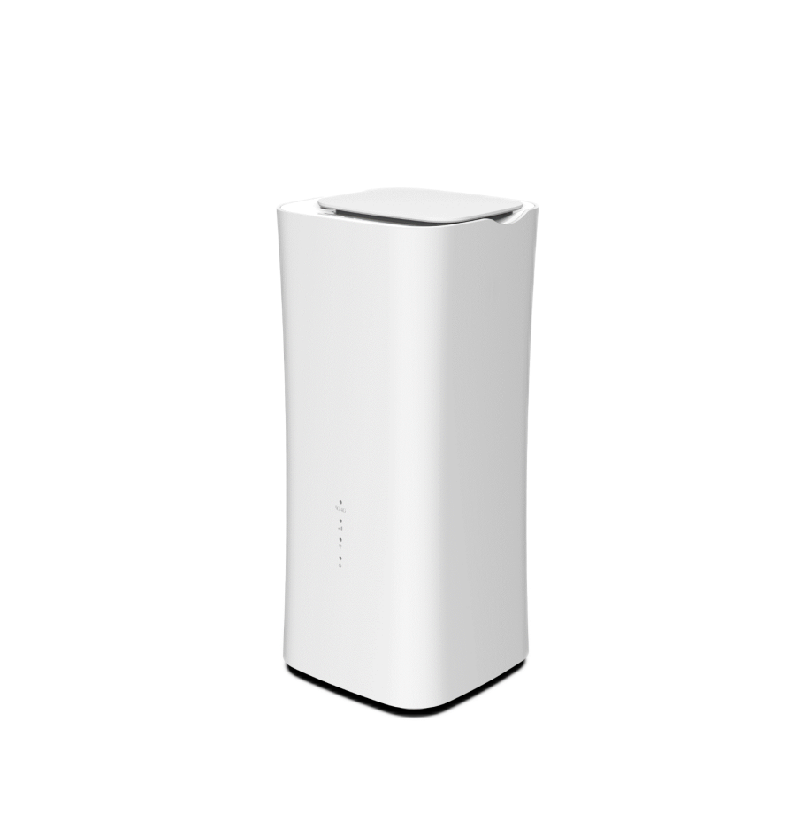CPX60P- V2

5G Sub-6 Indoor CPE

CAT20

5GNR/LTE/WCDMA

Wi-Fi 6 (802.11ax)

The CPX60P from BTI WIRELESS is a 5G indoor CPE, providing hyper 5G experience for global carriers and partners. This 5G router is compatible with 4G networks and spectrum and its actual throughput is 10 times higher than 4G LTE. With the CPX60P, consumers will enjoy faster wireless broadband data speeds versus fiber-based solutions, without the need for aerial or underground cabling. Whether you use it at home or in the office, the CPX60P provides a truly wireless broadband experience.

|  |
| --- |
| **KEY FEATURES** |
| * Qualcomm SDX62 chip solution * 5G NR and LTE-A CAT20 dual modes * Supports both SA and NSA * 1 SKU support European, Asian, and North American 5G NR bands * Supports Wi-Fi 6 (802.11ax) * Support two Gigabit Ethernet ports * Powerful software features, supporting all the router features * Web, TR069 and SNMP based device management |

|  |
| --- |
| **SYSTEM ELEMENTS** |
|  |

|  |  |  |  |
| --- | --- | --- | --- |
| **HARDWARE SPECIFICATIONS** | | | |
| **Technical Standard** | WAN | 5G NR/LTE/WCDMA | |
| LAN | IEEE 802.3/802.3u | |
| WLAN | IEEE 802.11b/g/n/ac/ax | |
| **Cellular Bands**  **( CPX60P(V2) )** | 5G NR | N1/N2/N3/N5/N7/N8/N12/N13/N14/N20/N25/N26/N28/N29/N30/N38/N40/N41/N48/N66/N71/N75/N76/N77/N78/N79 | |
| LTE | B1/B2/B3/B4/B5/B7/B8/B12/B13/B14/B17/B18/B19/B20/B25/B26/B28/B29/B30/B32/B34/B38/B39/B40/B41/B42/B43/B46(LAA)/B48(CBRS)/B66/B71 | |
| WCDMA | B1/B2/B4/B5/B8/B19 | |
| WLAN | 2.4 GHz and 5 GHz with QAM1024 support | |
| **External Port** | 2 x RJ45 gigabit ethernet port  1 x DC jack  1 x SIM slot (4FF) | | |
| **Antenna** | 4 build-in antenna for Cellular  2 build-in antenna for WIFI | | |
| **LED Indicators** | 1 x Power indicator  1 x WLAN indicator  1 x Net indicator  1 x Tri-color signal strength indicator | | |
| **Button** | 1 x reset button  1 x multi-function button | | |
| **MIMO** | DL: 4X4 MIMO, N1/2/3/7/25/30/38/40/41/48/66/70/77/78/79  UL: 2X2 MIMO, N38/41/48/77/78/79  WIFI 6 MIMO 2*2 | | |
| **Carrier Aggregation** | LTE: DL 5CA and UL 2CA  NR: 2CA | | |
| **Maximum Transmission**  **Power** | 5G NR sub 6 bands | | Class 3 -- 23 ± 1dBm |
| 5G NR HPUE bands  (n38/n40/n41/n77/n78/n79) | | Class 2 -- 26 ± 1dBm |
| 4G LTE | | Class 3 -- 23 ± 1dBm |
| LTE HPUE bands  (B38/B41/B42/B43) | | Class 2 -- 26 ± 1dBm |
| WCDMA | | Class 3 -- 23 ± 1dBm |
| **Cellular Data Throughput**  **(through the LAN port)** | 5G SA | | Downlink: 1 Gbps; Uplink: 900 Mbps |
| 5G NSA/ENDC | | Downlink: 1 Gbps; Uplink: 525 Mbps |
| LTE | | Downlink: 1 Gbps; Uplink: 150 Mbps |
| **Power Supply** | DC 12V/ 2A | | |
| **Power Consumption** | < 20W | | |
| **Dimensions (Maximum)** | 105 x 105 x 215 mm | 4.13 x 4.13 x 8.46 in | | |
| **Weight** | < 1 kg | 2.20 lbs | | |
| **Humidity** | 5% ~ 95% Non-condensing | | |
| **Temperature** | Working temperature: -10 °C ~ +45 °C | +14 °F ~ +113 °F  Storage temperature: -40 °C ~ +70 °C | -40 °F ~ +158 °F | | |

|  |  |  |
| --- | --- | --- |
| **SOFTWARE SPECIFICATIONS** | | |
| **Data Services** | 4 x APNs | |
| Multiple PDN | |
| IPV4/IPV6 dual stack support | |
| **LAN** | DHCP V4/V6 | |
| DNS and DNS proxy | |
| DMZ | |
| UPNP | |
| ALG | |
| MAC address Filtering | |
| **WLAN** | IEEE 802.11a/b/g/n/ac/ac Wave 2/ax | |
| Maximum rate of up to 1.8 Gbps | |
| Beamforming | |
| MU-MIMO | |
| Short guard interval (GI) in 20 MHz, 40 MHz, 80 MHz modes | |
| Priority mapping and packet scheduling based on a Wi-Fi Multimedia (WMM) profile | |
| Automatic and manual rate adjustment | |
| WLAN channel management and channel rate adjustment | |
| Service set identifier (SSID) hiding | |
| WPS | |
| Encryption: WEP, AES, and TKIP + AES | |
| Security mode: Open, WPA2.0 PSK, WPA1.0/WPA2.0 PSK, WEP Shared Key (four keys at most) | |
| **Management** | Version Management: Image checksum | |
| HTTP/FTP auto-upgrade | |
| TR069 | Upload/ Download the ACS specified file |
| Download the configuration file |
| Configure & queries parameters |
| Remote upgrade |
| Remote debugging operations |
| Cycle monitor |
| SNMP | |
| WebGUI/ CLI | Different level of user login priority with various limitation and display |
| Encryption backup current settings and restore the backup settings |
| Export diagnosis results and operation logs |
| Statistics of LAN link status, transmit and receive traffic and up time |
| Diagnostics | |
| USIM PIN management and card authentication | |
| USIM activation | |
| **VPN & Routing** | NAT mode | |
| Bridge mode/Bypass mode | |
| Port mirror | |
| ARP | |
| Port forwarding | |
| IPsec | |
| PPTP | |
| GRE tunnel | |
| L2TP V2/V3 | |
| L2TP BCP | |
| VPN pass-through | |
| **Security** | Firewall | |
| Mac address filtering | |
| IP address filtering | |
| URL filtering | |
| Access control | |
| HTTPS login from WAN | |
| DDOS attack protection | |
| Hierarchical user management | |

|  |  |
| --- | --- |
| **COMPLIANCE SPECIFICATIONS** | |
| **Environment Compliance** | Cold: IEC 60068-2-1 |
| Dry heat: IEC 60068-2-2 |
| Damp heat cyclic: IEC 60068-2-30 |
| Change of temperature: IEC 60068-2-14 |
| Shock: IEC60068-2-27 |
| Free fall: IEC60068-2-32 |
| Vibration: IEC60068-2-6 |

|  |  |  |
| --- | --- | --- |
| **ANTENNA SPECIFICATIONS** | | |
| 617 MHz ~ 960 MHz | 3 dBi | OmniDirectional |
| 1.7 GHz ~ 2.7 GHz | 6 dBi | OmniDirectional |
| 3.3 GHz ~ 5 GHz | 6 dBi | OmniDirectional |

Contact Us

[www.btiwireless.com](http://www.btiwireless.com)

[sales@btiwireless.com](mailto:sales@btiwireless.com)