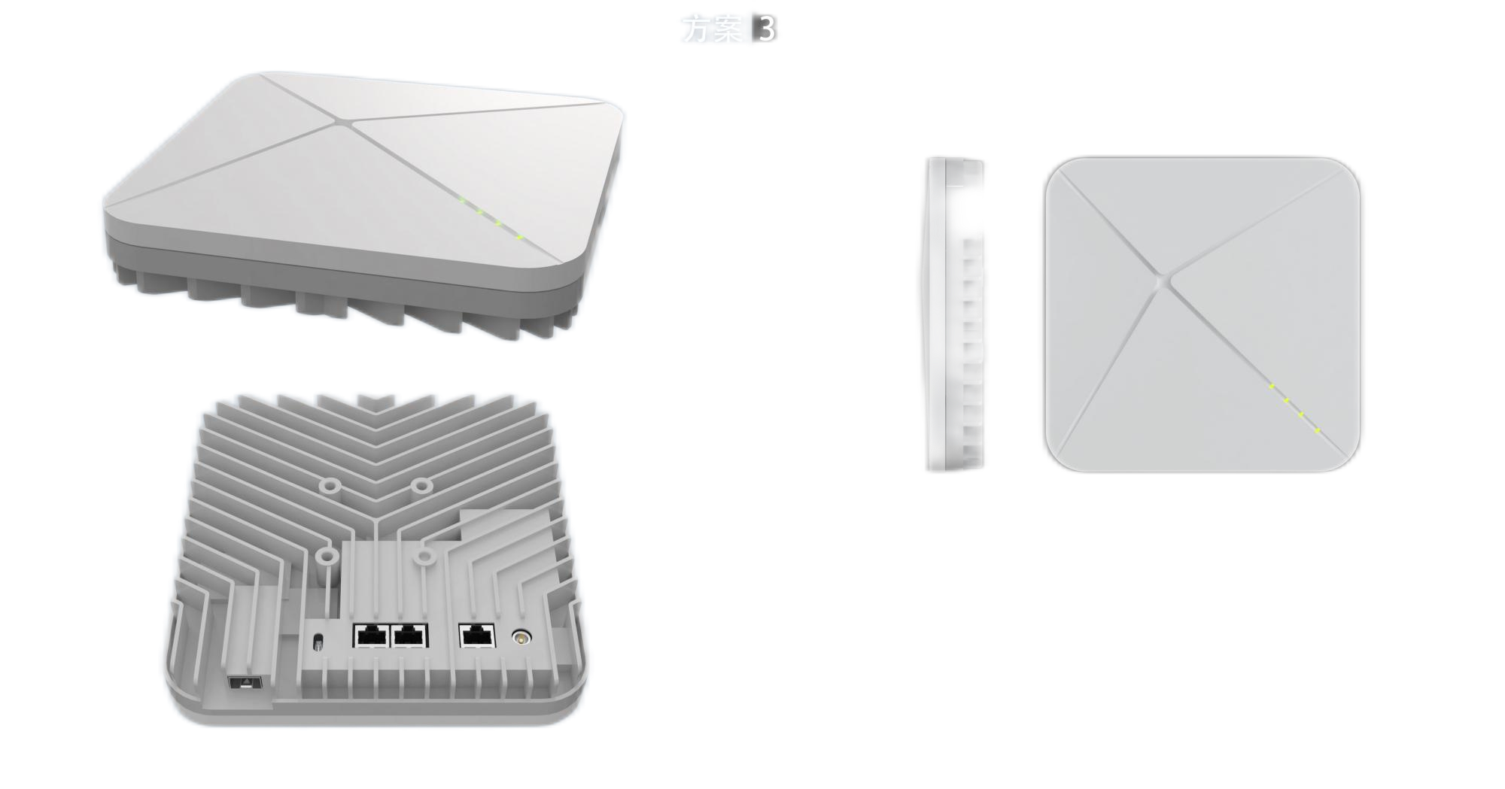
nCELL-F2240
5G NR Femtocell

2 x 2 MIMO
2 x 250 mw
128 RRC Subscribers

The nCELL-F2240 from BTI is an enterprise-level 5G integrated Femtocell applying 5G NR technology. The product connects to the backbone network through wired backhaul and provides 5G access for terminals. It supports the transmission of voice and data with indoor wireless broadband coverage.

KEY FEATURES
- Integrated design of baseband and radio head
- Based on 3GPP R16 technology with high-speed data and low latency services
- Supports up to 100 MHz bandwidth
- 35W low power consumption
- Convenient networking, plug and play solution, easy and flexible deployment
- Plentiful security service provides real-time protection, to prevent potential security risks and illegal intrusion
- Web-based management, convenient and intuitive
- Complete network management function
- Humanized indicator light, easy to observe and manage equipment status
- IP3X protection level

APPEARANCE
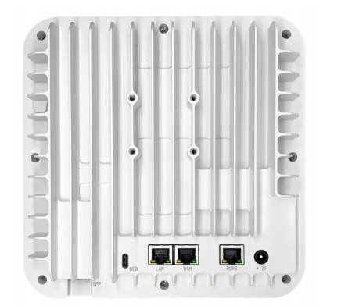

HARDWARE SPECIFICATIONS
Work Style | 5G SA
Working Frequency | SKU1: N41(2496-2690Mhz)  SKU2: N48/N78(3500Mhz-3800Mhz)  SKU3: N79(4800Mhz-5000Mhz)
Working Bandwidth | 40/60/80/100Mhz
Transmit Power | 2 x 24 dBm
frequency Error | ± 0.1 ppm
Sensitivity | < -96 dBm
EVM | 64QAM/256QAM, ≤5%
ACLR | ≤-45dBc
Synchronization | Support GPS, 1588v2
MIMO | 2 x 2
Equipment Size | 200 x 200 x64mm(L x W x H)
Installation Method | Wall hanging, ceiling
Power Consumption | < 35W
Power Supply | 12V DC/10A
Weight | < 1.5 kg
Operating Temperature | -10 °C ~ +40 °C

SOFTWARE SPECIFICATIONS
Technical Standard | 3GPP Release 16
Peak Rate (100 MHz Bandwidth) | 7D2U: DL: 810 Mbps (256QAM)/ 3U1D: UL: 480 Mbps (64QAM)
Operational Capacity | 128 Subscribers
Scheduling Method | 3GPP standard QCI
Network Management Interface | Supports TR069 interface protocol
MTBF | 5 Years
MTTR | < 1 hour
O&M | Remote/local maintenance, based on SSH protocol  Online status management  Performance statistics  Fault management  Configuration management  Local or remote software upgrade and loading  Supports log  Connectivity diagnosis  Self-start and self-configuration deployment  Alarm reporting  Supports KPI reporting  User information tracking

Contact Us Today
www.btiwireless.com
sales@btiwireless.com

