-

**Network Management System**

Friendly web-based GUI

Without the written permission of us, no part of this publication may be copied, transmitted, transcribed, stored in a retrieval system or translated into any language in any form (electronic, mechanical, photocopying, recording or other).

All copyrights, confidential information, patents, design rights and other intellectual property rights of any nature contained in this agreement are and will continue to be the exclusive property of us. The information provided here is believed to be accurate and reliable.

Summary

NMS (Network Management System) is a comprehensive management software that controls and monitors base station and CPE equipment supporting TR069 communication protocol. NMS can be located in the front-end computer room to manage a single device, or it can be located in a centralized location to manage multiple devices. NMS is based on the most advanced mechanism and technology, and a single set software can manage and monitor up to 10,000 devices.

The management system includes the following extensive functions:

Data Statistic Equipment Management

Core Network Management Configuration Management

Alarm Management Performance Management

Upgrade Management Log Management

System Management Task Management

Authority Management Platform Monitoring

Block Diagram

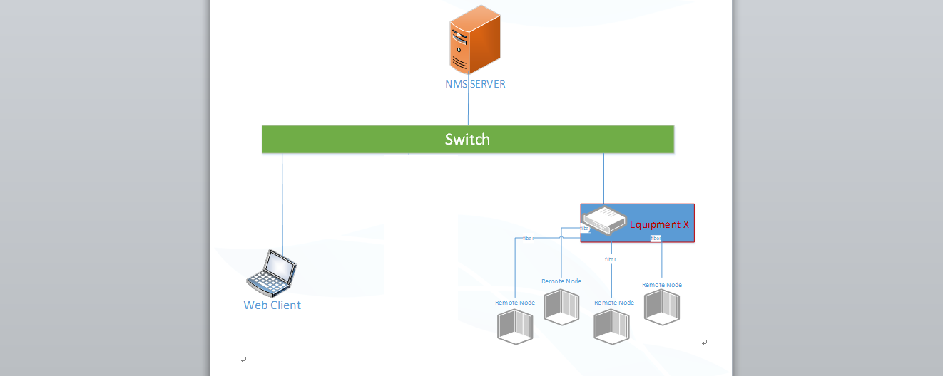

System Requirements

|  |  |  |
| --- | --- | --- |
| **Hardware** | **Quantity of NE ＜ 100** | **100 ＜ Quantity of NE ＜ 10000** |
| CPU | 4 cores or more, 1.5 GHz or more | 8 cores or more, 2.1GHz or more |
| RAM | 16GB or more | 64GB or more |
| SSD | 200GB or more | 2TB or more |

|  |  |
| --- | --- |
| **Software** | |
| Operating system | Rocky 9.4 or higher |
| Language | English |
| Database | MYSQL 8.0.21 |
| Tomcat | Tomcat 9 jre11 |
| Rabbitmq | 3.8.7 |
| Redis | 6.0.5 |
| Docker | 19.03.9 |
| Docker-compose | 2.17.2 |

Function

|  |  |  |
| --- | --- | --- |
| **Function** | |  |
| Menu on NMS | |  |
| Dashboard | Dashboard | Show the quick links and statistical information |
| Base Station | gNB Monitor | gNB basic information monitoring and gNB configuration |
| eNB Monitor | eNB basic information monitoring and eNB configuration |
| MML | MML and MML Script modify device configuration |
| Upgrade | Base station upgrade files and upgrade tasks management |
| Reboot | Base station restarting task management |
| Shutdown Task | Base Stations Remote Shutdown Management |
| Backup/Restore | Configuration backup and restore |
| Log | Base station log management, base station gather log, operation log, and parameter value change log. |
| Topo | Base station topology |
| CBSD CertFile | CBSD certification file management |
| CPE | CPE Monitor | CPE information monitoring and CPE configuration |
| Upgrade | CPE upgrade files and upgrade tasks management |
| Reboot | CPE reboot management |
| Log | CPE log management, CPE log file, operation log, and parameter value change log. |
| CBSD CertFile | CBSD certification file management |
| Core Network* | Configuration | Query and configure core network parameters |
| Alarm | Alarms raised by core |
| Element Information | Check basic information of core element |
| UE Info | Manage and check the UE information under the core |
| GIS | NE Location | GPS location display on the map |
| Site | Site | Manage the site location information |
| Device Group | Device Group | Manage devices in groups |
| Alarm | Alarm View | Alarm management, including current alarms, historical alarm information, alarm filtering, alarm email forwarding, alarm synchronization configuration, and alarm statistics |
| Alarm Library | Alarm information and the introduction of the alarm |
| Performance | KPI View | Check the KPI of different NE |
| KPI Measurement | Upload status of base station PM files |
| KPI Management | KPI management |
| KPI Alarm | KPI alarm management |
| Advance | SAS | CBRS Domain Proxy |
| Batch Task | Monitor | Parameter value monitoring and display |
| Configuration | Batch configuration management |
| MR Mange | Measurement Report | MR file collection task management |
| MR File | MR file management |
| Analyze | MR file analysis |
| Device Blocklist | Device Blocklist | Device blocklist management |
| System | Setting | System configuration management |
| SSH | SSH Proxy |
| PING | PING detecting tool |
| TCP Dump | NMS packet capture |
| NTP | NMS NTP management |
| Load | Server load monitoring |
| Logs | NMS log management, including NMS operation logs, northbound access logs and NMS platform logs |
| Data Model | Configuration management |
| Upgrade | NMS update and roll-back management |
| License | License management |
| Authority | Authority management |
| Area | Area management |

*Manage the core which build-in integrated gNB

Dashboard and gNB Management 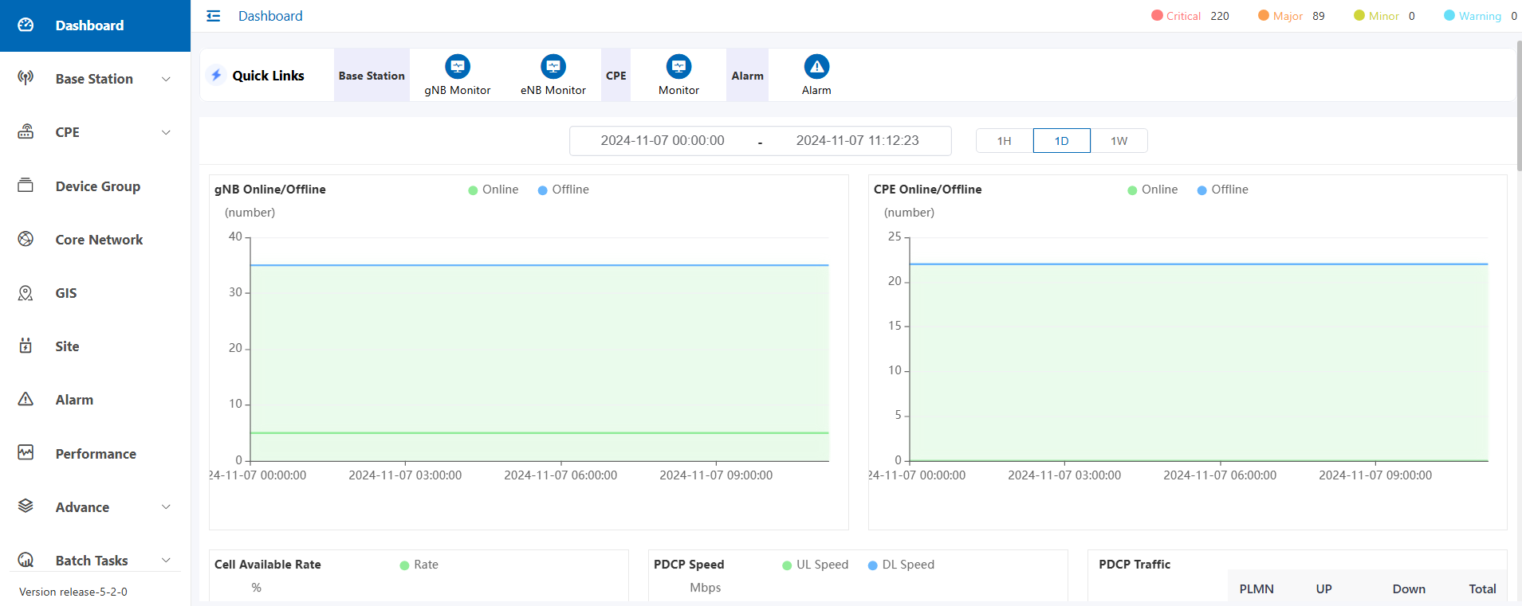

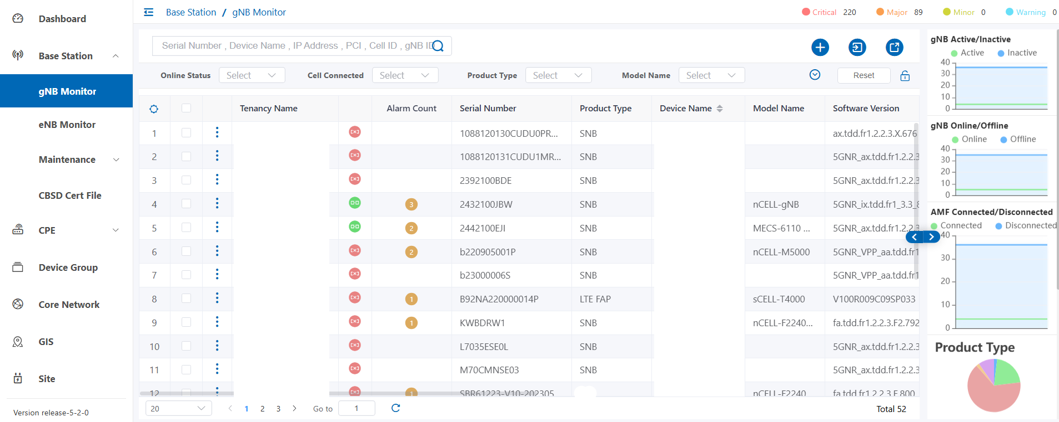

Ordering Information

|  |  |
| --- | --- |
| **Part Code** | **Part Description** |
| license1 | Network Management System, with XX element license. Including server. |
| license2 | Network Management System, with XX element license. Excluding server, with 1-year free remote service. |
| license3 | Network Management System, maintenance cost for 1 year. |

Contact Us Today

[www.btiwireless.com](http://www.btiwireless.com)

[sales@btiwireless.com](mailto:sales@btiwireless.com)