MDN80I
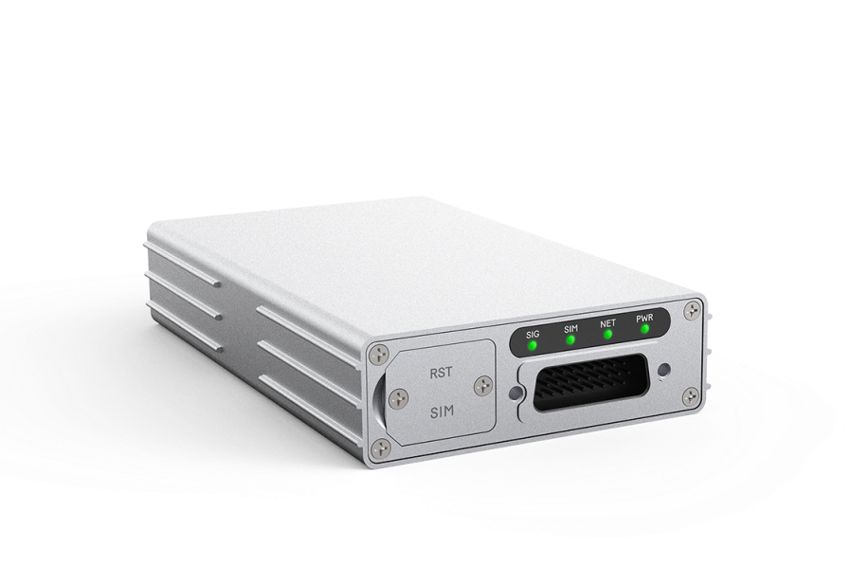
5G Ruggedized Router

CAT20
5GNR/LTE/WCDMA
RS485
IP65

MDN80I Ruggedized Router from BTI is designed for industrial applications that converts 5G wireless signals into Gigabit Ethernet, providing stable and high-speed 5G access for the devices.

Designed for both indoor and outdoor harsh industrial environments, MDN80I meets high standards in vibration tolerance and is ideal for operations in robot, AGV, AMR, unmanned delivery cars, drones, logistics, automated manufacturing, port and other outdoor applications. MDN80I can also offer precise information about its real-time location; its built-in GNSS receiver allows GPS, GLONASS, Beidou and Galileo constellations.

KEY FEATURES
- Qualcomm SDX62 chipset solution
- 5G NR and LTE-A CAT20 dual mode
- Supports both SA and NSA
- Global/CBRS bands supported
- Ruggedized and anti-vibration design
- Powerful software features
- Web, TR069 and SNMP based device management
- Supports 2.5G Ethernet port and RS485 industrial interface
- IP65 rating for outdoor environment

SYSTEM ELEMENTS
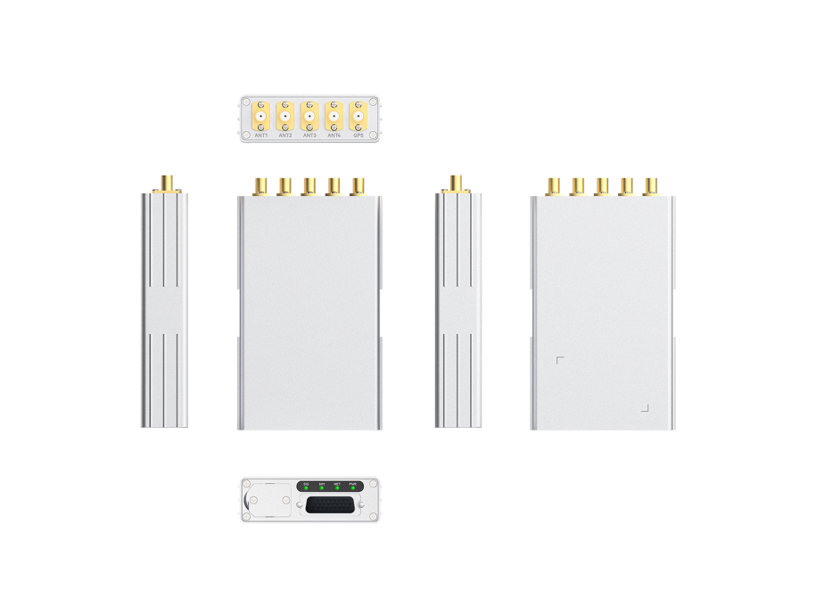

HARDWARE SPECIFICATIONS
Chipset | Qualcomm SDX62 SoC
Cellular Bands(MDN80I-A Europe & Asia version) | 5G NR |  | n1/n3/n5/n7/n8/n20/n28/n38/n40/n41/n75/n76/n77/n78
Cellular Bands(MDN80I-A Europe & Asia version) | LTE |  | FDD B1/B3/B5/B7/B8/B20/B28/B32  TDD B38/B40/B41/B42/B43
Cellular Bands(MDN80I-A Europe & Asia version) | WCDMA |  | B1/B5/B8
Cellular Bands(MDN80I-B North American version) | 5G NR |  | n2/n5/n7/n12/n13/n14/n25/n26/n29/n30/n38/n41/n48/n66/n70/n71/n77/n78
Cellular Bands(MDN80I-B North American version) | LTE |  | FDD B2/B4/B5/B7/B12/B13/B14/B25/B26/B29/B30/B66/B71  TDD B38/B41/B42/B43/B48  LAA B46
Category | Rel-16/Sub6 5G & CAT20
GNSS | GPS/GLONASS/BeiDou/Galileo
Network Mode | Supports SA/NSA
External Port | 1 x 2.5G Ethernet port  1 x RS485  1 x SIM Slot (4FF)
LED | 4 LED Indicators (PWR, NET, SIM, Tri-color SIG)
Antenna Port | 4 x LTE/NR Antenna  1 x GNSS
Carrier Aggregation | LTE: DL 5CA and UL 2CA  NR: 2CA
MIMO(MDN80I-A  Europe & Asia version) | Downlink | 5G NR:  4×4 MIMO on n1/n3/n5/n7/n8/n20/n28/n38/n40/n41/n75  n76/n77/n78  LTE:  4×4 MIMO on B1/B3/B5/B7/B8/B20/B28/B32/B38/B40/B41  B42/B43
MIMO(MDN80I-A  Europe & Asia version) | Uplink | 5G NR: 2×2 MIMO on n38/n41/n77/n78
MIMO (MDN80I-B  North American  version) | Downlink | 5G NR:  4×4 MIMO on n2/n5/n7/n12/n13/n14/n25/n26/n29/n30/n38  n41/n48/n66/n70/n71/n77/n78  LTE:  4×4 MIMO on B2/B4/B5/B7/B12/B13/B14/B17/B25/B26/B29/B30/B38/B41/B42/B43/B48/B66/B71
MIMO (MDN80I-B  North American  version) | Uplink | 5G NR: 2×2 MIMO on n38/n41/n48/n77/n78
Maximum throughput | Downlink | 5G NR SA (Gigabit Ethernet port) |  |  | 2.4Gbps
Maximum throughput | Downlink | 5G NR NSA (Gigabit Ethernet port) |  |  | 2.5Gbps
Maximum throughput | Downlink | 4G LTE (Gigabit Ethernet port) |  |  | 1.6Gbps
Maximum throughput | Downlink | WCDMA (Gigabit Ethernet port) |  |  | 42Mbps
Maximum throughput | Uplink | 5G NR SA Sub 6 |  |  | 900Mbps
Maximum throughput | Uplink | 5G NR NSA Sub 6 |  |  | 550Mbps
Maximum throughput | Uplink | 4G LTE |  |  | 200Mbps
Maximum throughput | Uplink | WCDMA |  |  | 5.76Mbps
Maximum transmission power | 5G NR Sub 6 bands |  |  | Class 3 (23 dBm ±2 dB)
Maximum transmission power | n41/n77/n78 HPUE |  |  | Class 2 (26 dBm +2/-3 dB)
Maximum transmission power | 4G LTE |  |  | Class 3 (23 dBm ±2 dB)
Maximum transmission power | B38/B41/B42 HPUE |  |  | Class 2 (26 dBm ±2 dB)
Maximum transmission power | WCDMA |  |  | Class 3 (24 dBm +1/-3 dB)
Power supply | DC 8~24V, 12V default
Power Consumption | ＜24W
GNSS | Support GPS, GLONASS, Beidou and Galileo
Dimensions | 125mm x 75mm x 25mm
Weight | 420g
Humidity | Operation humidity: 5% - 95% (non-condensing)  Storage humidity: 5% - 95% (non-condensing)
Temperature | Operating temperature: -40 °C ~ +70 °C  Storage temperature: -40 °C ~ +85 °C

SOFTWARE SPECIFICATIONS
WAN | Multi-APN support, maximum four
WAN | IP pass-through
WAN | IPv4/v6 dual stack
LAN | IEEE 802.1Q VLAN
LAN | DHCP Server
LAN | DNS and DNS proxy
LAN | DMZ
LAN | Multi-cast/ Multi-cast proxy
Protocol | Routing: Static routing
Device management | TR069
Device management | SNMP v2
Device management | WebGUI
Device management | Software upgrade via Web UI/TR069/FOTA
Device management | USIM PIN management
Routing Mode | Route mode
Routing Mode | Bridge mode
Routing Mode | NAT mode
Routing Mode | Static Route
Routing Mode | Port Mirror and Port Forwarding
Routing Mode | IPV4/IPV6 dual stack
VPN | PPTP
VPN | GRE tunnel
VPN | L2TP V2/V3
Security | Firewall
Security | Mac address filtering
Security | IP address filtering
Security | URL filtering
Security | Access control
Security | HTTPS login from WAN
Security | DOS attack protection
Security | Two level of user authority

COMPLIANCE SPECIFICATIONS
Environment Compliance | Protection rating: IP65
Environment Compliance | Shockproof: ISO 16750-3 : 2012 ( E）

Contact Us
www.btiwireless.com
sales@btiwireless.com

