nCELL-RU4240
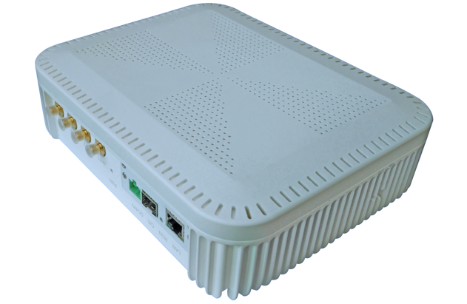
5G Pico Remote Radio Unit

4T4R
24dBm
5GNR
IBW 200MHz

The nCELL-RU4240 from BTI WIRELESS is a remote unit in a 5G extended leather base station and usually needs to be used in conjunction with an extension unit (EU) and a baseband unit (BBU) to achieve 5G wireless signal coverage. This 5G pRRU remote unit adopts digital technology and uses optical fiber to carry wireless signals for remote coverage. It is mainly used in indoor coverage scenarios.

KEY FEATURES
- 4T4R design, can be upgraded to 200 MHz processing bandwidth
- Compatible with CPRI and eCPRI interfaces
- Comply with O-RAN specifications, and can be interconnected with expansion units or BBUs of different manufacturers
- The product is small in size, high in efficiency, light in weight, and convenient for indoor installation
- Supports remote upgrade and maintenance

SYSTEM ELEMENTS
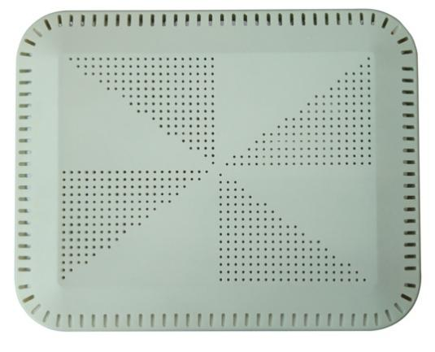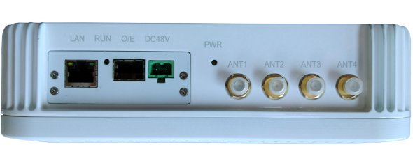

HARDWARE SPECIFICATIONS
Working Frequency | Option 1: 2515~2675 MHz  Option 2: 3300~3600 MHz  Option 3: 3500 ~ 3700 MHz  Option 4: 3700 ~4000 MHz  Option 5: 4700 ~4900 MHZ
Working Bandwidth | 20/40/60/80/100 MHz
Number of RF Channels | 4T4R
Output Power | 24dBm per channel
EVM | < 17.5% QPSK (maximum power)  < 12.5% 16QAM (maximum power)  < 8% 64QAM (maximum power)  < 3.5% 256QAM (maximum power)
Frequency Error | < 0.01ppm
ACLR | > 45dB
Turn Off Power | Below -89dBm/MHz
Spurious Emission | Meets 3GPP TS 38.104 V16.0.0 protocol requirements
Receiver Sensitivity | The throughput loss is not more than 5%, refer to the measurement channel G-FR1-A1-5, the sensitivity of the single-channel receiver is not higher than -94dBm. (Receiver sensitivity is subject to the tested BBU)
Block | In-channel selectivity, ACS, in-band narrowband blocking, out-of-band blocking, receiving intermodulation, WIFI coexistence and other indicators, under various interference signal conditions required in 3GPP 38.104, the sensitivity of single-channel receivers is not high under any circumstances At -88dBm. (The receiver sensitivity is subject to the tested BBU)
Antenna Interface | Built-in antenna or external antenna (SMA-F)
Antenna Gain (Internal Module) | ≥ 2 dBi
Operating Temperature | -5 °C ~ +55 °C | 23 °F ~ +131 °F
Powered Supply | 48V
Power Consumption | < 30W
Size | 219 x 174.5 x 62 mm | 8.62 x 6.87 x 2.44 in
Weight | 1.6 kg | 3.53 lbs
Noise Figure | 2db@low noise amplifier

Contact Us
www.btiwireless.com
sales@btiwireless.com

