nCELL-TR

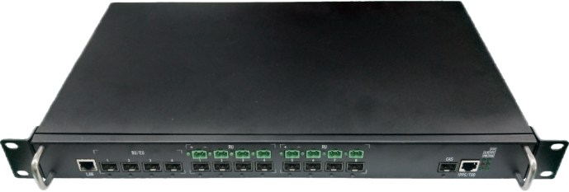5G Expansion Unit

4*10Gbps eCPRI Interface

8*10Gbps CPRI Interface

The nCELL-TR from BTI WIRELESS is 5G EU that mainly used for indoor sub-coverage. It is a radio frequency remote CPRI data aggregation unit. It receives the downlink baseband data sent by the BBU, and then transmits it to the RRU after demultiplexing, and the uplink baseband data of the RRU undergoes a certain combination of processing. Send back to the BBU to realize communication with the BBU. The unit has a built-in RRU remote power supply circuit, which supplies power to the RRU through a composite optical cable.

|  |
| --- |
| **SYSTEM ELEMENTS** |
| 0080730201ae52a698c117da95452c0396 |

|  |  |
| --- | --- |
| **HARDWARE SPECIFICATIONS** | |
| **Input Power** | AC176V ~ AC264V; 45 Hz ~ 65 Hz |
| **Overall Size**  **(Length x Width x Height)** | 482.6 x 261 x 44.5 mm | 19 x 10.27 x 1.75 in |
| **Weight** | ≤ 6 kg | 13.22 lbs |
| **Power Supply Capacity** | 8*40W, the power supply capacity of each remote port is 40W |
| **Power Consumption** | ≤ 55W (static) |
| **Protection Level** | IP31 |
| **Noise Requirements** | < 45dBA |
| **Operating Temperature** | -20 °C ~ +55 °C | -4 °F ~ +131 °F |
| **Transmission Interface** | BBU/EU side: 4*10Gbps eCPRI |
| RRU side: 8*10Gbps CPRI |
| **Networking Method** | Star |
| **Cascade Capability** | EU interface, level 2 |
| **Reach Ability** | Composite optical cable 200 meters |
| **Synchronize** | Supports to extract clock synchronization from BBU interface, supports GPS or BD dual-mode work, with automatic switching function |

|  |  |
| --- | --- |
| **INTERFACE SPECIFICATIONS** | |
| **AC220V** | AC176V ~ AC264V |
| **ON/OFF** | Switch |
| **BBU/EU (1-4)** | SFP+ optical port, 10/25GHz adaptive, connect to BBU or EU extension |
| **RRU (1-8)** | SFP+ optical port, 10/25GHz adaptive, connect to RRU |
| **DC1-DC8** | DC54V 2 core |
| **LAN** | RJ-45, commissioning port |
| **1PPS/TOD** | RJ-45, clock synchronization interface |
| **GPS** | GPS+BD synchronous antenna interface |
| **GND** | M4, grounding post |

|  |  |
| --- | --- |
| **INDICATOR SPECIFICATIONS** | |
| **PWR** | Power indicator green LED |
| **RUN** | Operation indicator Green LED |
| **ALM** | Alarm indicator red LED |
| **GPS** | Sync indicator Green LED |
| **PTP** | Sync indicator Green LED |
| **BBU/EU (1-4)** | SFP+ optical port synchronization indicator green LED |
| **RRU (1-8)** | SFP+ optical port synchronization indicator green LED |

Contact Us Today

[www.btiwireless.com](http://www.btiwireless.com)

[sales@btiwireless.com](mailto:sales@btiwireless.com)