Integrated-gNodeB
M4460 Installation Method

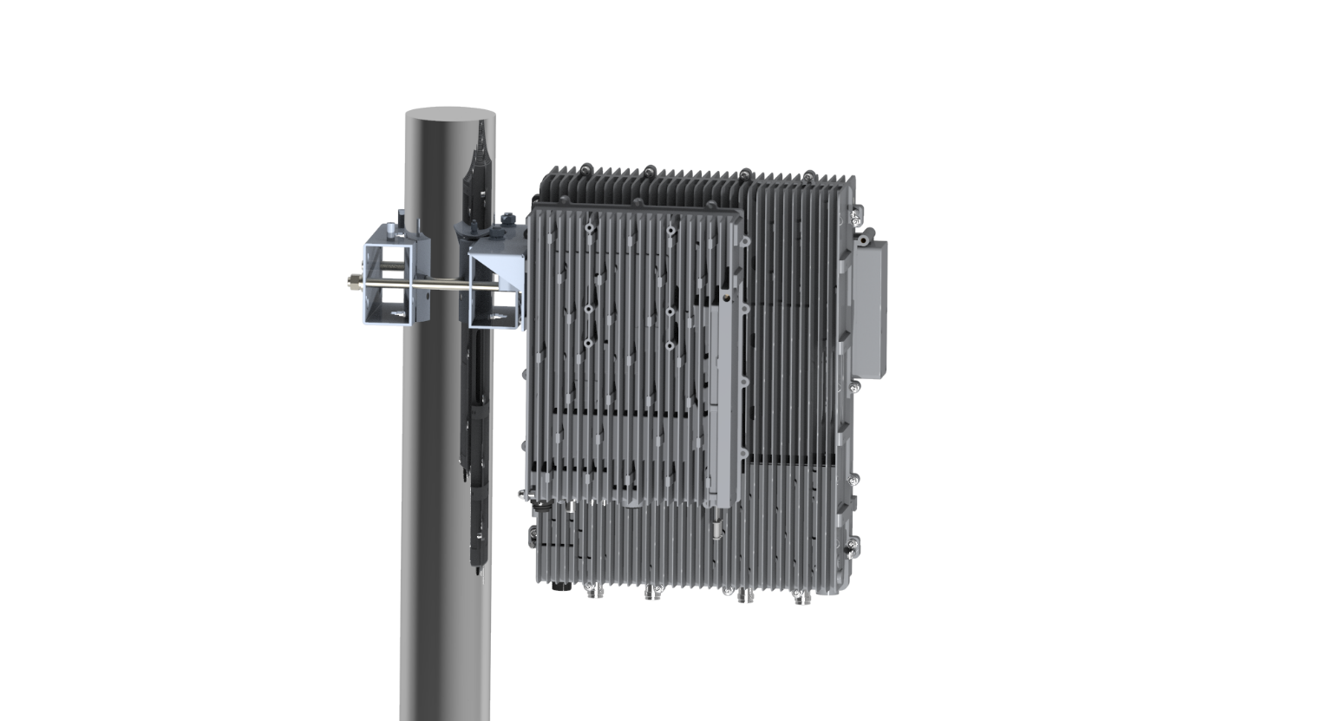

Content

Preface 3
Safety Instructions 3
Installation Preparation 4
Unpacking and Inspecting 4
Inspecting the Packing Container 4
Unpacking the Device 4
Verifying the Contents 4
Inspecting the Device 5
Installation Preparation 5
Site Investigation 5
Installation Tools 5
Torque Settings 5
Installing the M4460 6
Accessories List 6
Installation Procedure 7

Preface

Safety Instructions
All the following “Safety Precautions” must be observed during the entire installation and operation of the BTI system.
The BTI system components are designed for maximum safety and reliability when they are installed, used, and maintained by trained and qualified technicians in accordance with the procedures and instructions contained in this manual. To assure the safe operation of your system, always follow the safety and operational recommendations in this manual.
- The shells of the device have protective ground terminals. During installation, connect the ground terminals securely to the protective building ground with yellow and green conductors or with braided ground wire. The aerial and feeder must be adequately grounded.
- The power source must be within the required range of the device. The rated voltage range for the AC power supply system is 100 ~ 240V AC, and the rated frequency range is 50Hz / 60Hz. The ground terminal of the three-core power socket used at the device installation site must be securely connected to the protective building ground.
- To avoid injuries or damage, use care, and obtain assistance before lifting any heavy system components or equipment.
- Pick an ideal easy-to-reach location for installation convenience.
- The socket-outlet shall be easily accessible.

Installation Preparation

Unpacking and Inspecting
This section discusses the procedures for receiving the shipment, inspecting the packing container, unpacking, and inspecting the device.

Inspecting the Packing Container
Handle the packing container carefully. Inspect the packing container immediately on arrival at the installation site to verify that no obvious damage occurred during shipment. Ensure that the container is sound and that the waterproof and vibration warning notices are still obvious. If possible, always inspect the equipment in the presence of the delivery person.
If any damage is observed:
- Do not open or unpack the container.
- Immediately contact the transportation carrier and notify them of the damage.
- File a claim with the carrier once you determine the extent of any damage.
- Return it to BTI’s nearest RMA facility and contact BTI for RMA processing.

Unpacking the Device
If the container appears to be in satisfactory condition:
- Ensure both user and supplier representatives are in attendance during shipment inspection.
- Confirm where you will store the device.
- Ensure procedures are in place to handle the device and other equipment properly.
- Ensure the following tools are available to unpack the shipment: hammer, paper cutter, and crowbar.
- Open the packing container carefully. The device is contained in a protective package inside the packing container; however, caution is still necessary so as not to damage the internal package and device.
- Remove the internal package from the packing container.
- Unpack the device from the internal package carefully.

Verifying the Contents
To verify the contents of the package:
- Verify that the contents and quantities agree with the Delivery Packing List.
- Check the device model against the Delivery Packing List.
- Notify BTI immediately if any discrepancies are discovered, to verify whether the complete and correct shipment has been received.

Inspecting the Device
After unpacking the device, place the device on solid ground and check the following to ensure the device has not been damaged:
- Inspect the device’s appearance, overall dimensions, and weight.
- Check that the device has not been deformed or bent in any way.
- Check that there are no warps, scratches, bubbles, or dirt marks.
- Check that there are no loose, missing or incorrectly fastened screws.
- Check that the installation slots in the cabinet sub-rack are rectangular.
- Ensure that the guide bar has not been damaged and the fittings and auxiliary parts are intact.
- Check that the silk-screened images on the device are visible and intact.

Installation Preparation

Site Investigation
Before installation, the installer should contact the project director to ensure that the site is suitable for installation. Details required include information about the installation site, such as whether there is an iron tower or high mast nearby, the surrounding environmental conditions such as temperature and humidity, the power source, and so on.
Installation staff should complete a site investigation with the project director before construction and conduct field observation of the installation site and the coverage area of the device, to confirm factors such as signal intensity, signal quality, the required coverage range, device location, antenna-feeder system, and power supply system.
Note: Only maintenance personnel or users who understand the reason for access and are experienced with restricted area access and understand the necessary preventive measures should access the installation site.

Installation Tools
The following equipment and tools are required for a successful installation:
Electric percussion drill / Screwdriver / Wrench

Torque Settings
Type | M3 | M6 | M10
Specified Torques | 0.6Nm | 5Nm | 50Nm

Accessories List

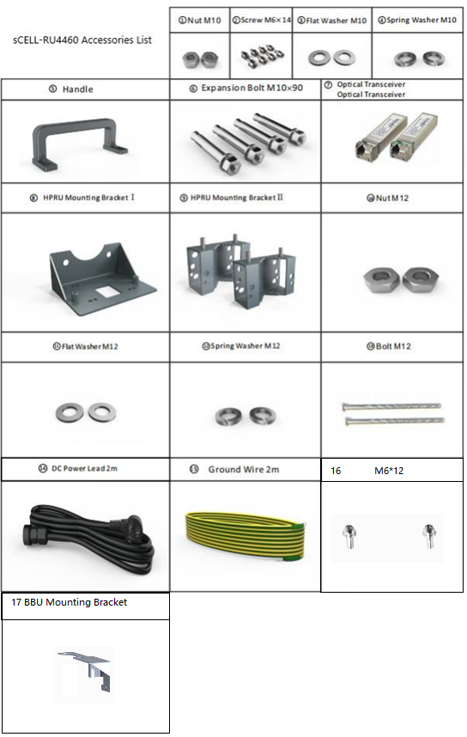

Installation Procedure
Follow the procedure to install the M4460.
- Pole Installation
RRU
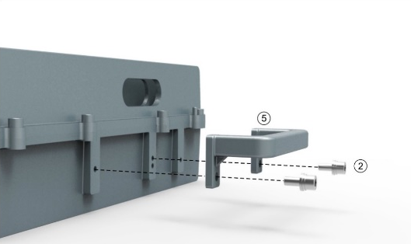 | Step 1: Using a T5 wrench, secure the handle to the side of the device with M6*14 screws
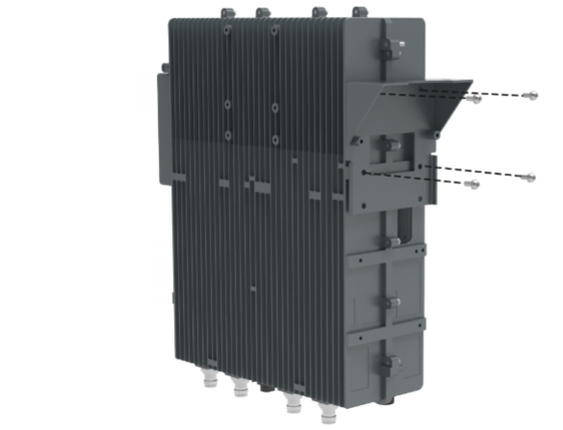  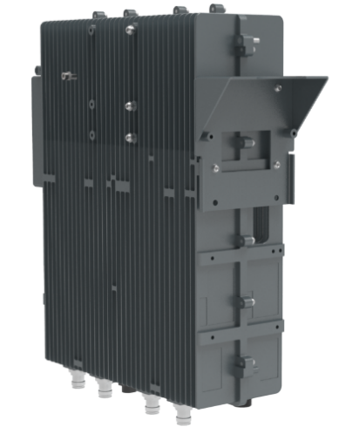 | Step 2: Using a T5 wrench, secure the type I bracket to the left side of the device with M6*14 screws
POLE PARTS
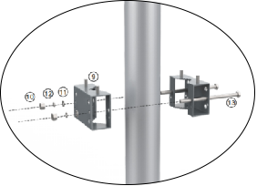 | Install the bracket II and Bracket III to the pole.
HANG THE RRU
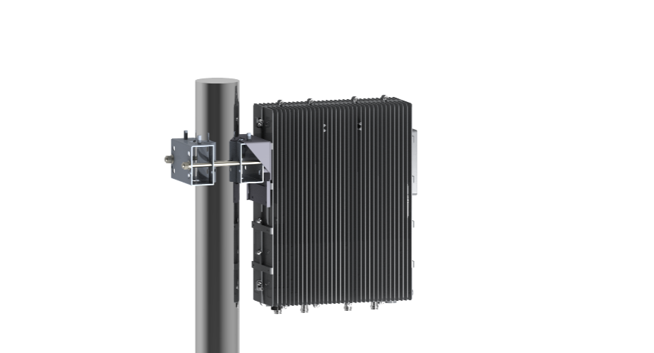 | Step1: Hang the equipment on the mounting bracket
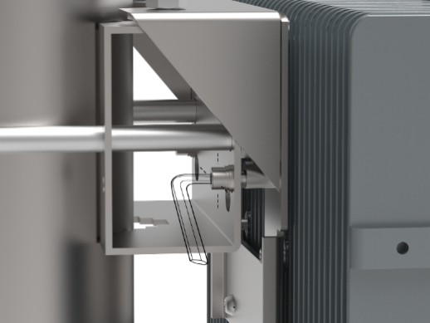 | Step2: secure with the M14 nut
BBU
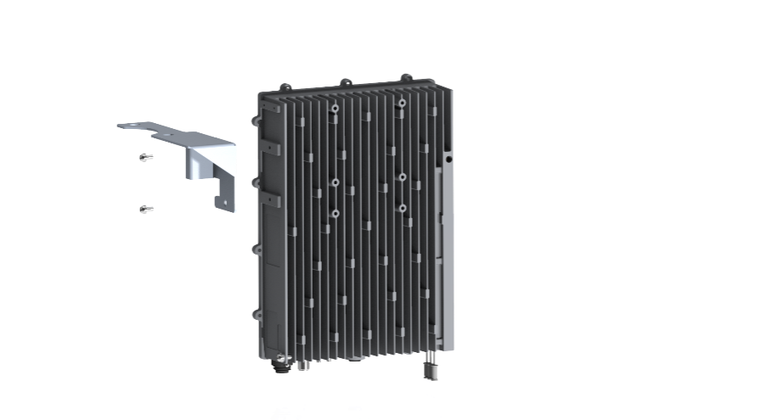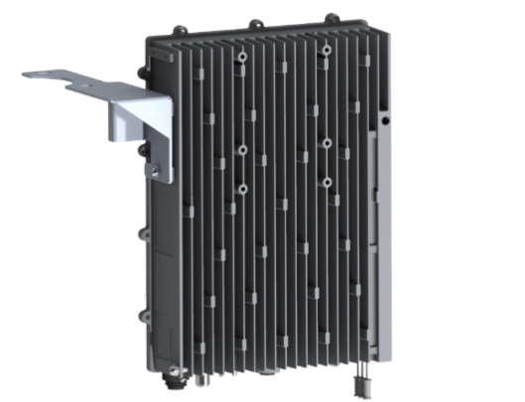 | Using a T5 wrench, secure the BBU Mounting bracket to the left side of the device with M6*12 screws
HANGE THE BBU
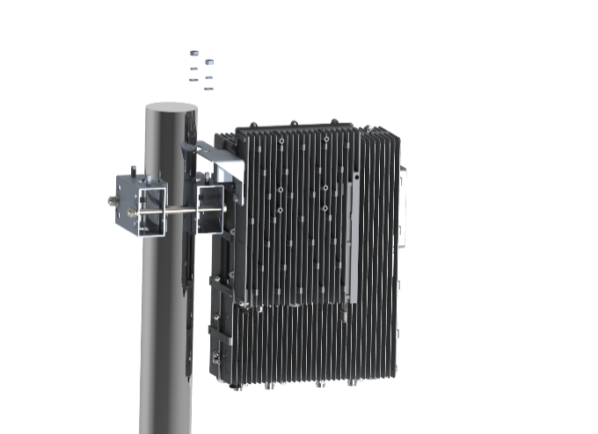  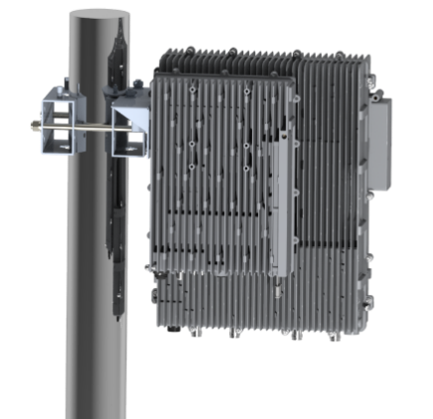 | Hang the BBU on the mounting bracket and secure with the M10 nut
ADDITIONAL OPERATION
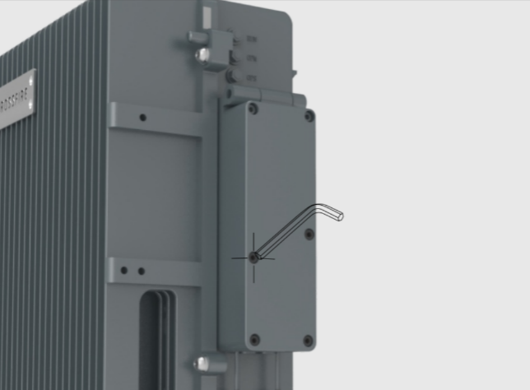  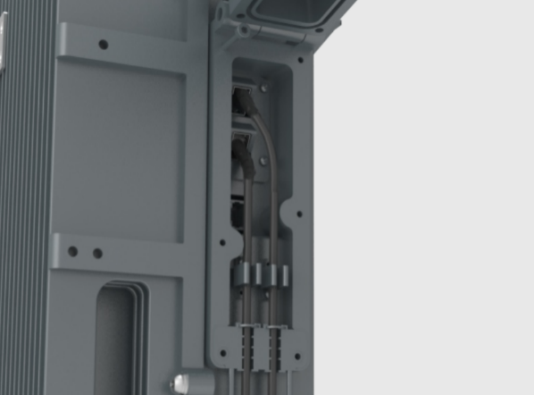 | Step 1: Open the chassis on the right side of the RU4460 and connect to the SFP optical module.  Install the power cord and ground wires.
.

Additional accessories are required to install the poles and are purchased separately.
Note: The diameter of Pole shall not be over 110mm or less than 55mm.

