nCELL-T5000
5G Virtualized BaseBand Units

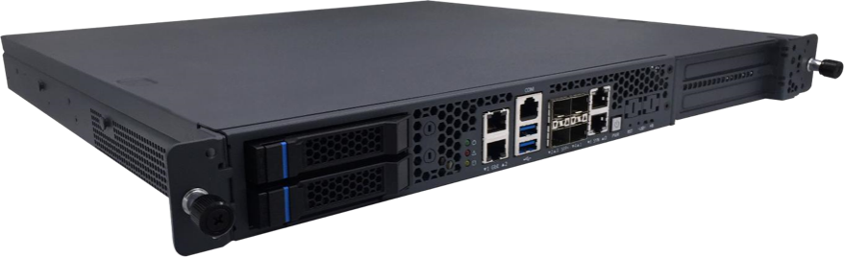
5GNR
4 Cells
3GPP Release R16
DL 1.5Gbps/UL 260Mbps
800 Active Users per BBU

The nCELL-T5000 from BTI WIRELESS is used to realize 5G NR base station processing unit to centrally control and manage the entire base station system. It realizes direct access and data interaction with 5G core network, with NGAP and XnAP interface. Also, the product realizes 5G NR access network protocol stack function, RRC, PDCP, SDAP, RLC, MAC and PHY protocol layer functions, as well as baseband processing functions.

PROCESSOR PARAMETERS
CPU | CPU Intel® Xeon® D-2177NT Processor 105W (14C/28T)  CPU Intel® Xeon® D-2187NT Processor 110W (16C/32T)
Photolithography | 14nm
Processor Base Frequency | XeonD-2177NT Processor – 1.9GHz  XeonD-2187NT Processor – 2.0GHz
Maximum Turbo Frequency | 3.00 GHz
Cache | 19 MB
Memory Type | DDR4-2666
Supported ECC Memory | Yes
Maximum Number of Memory Channels | 4
Maximum Memory Speed | 2667 MHz
Maximum Memory  (Depending on Memory Type) | 256 GB
Chipset | Intel® Xeon® SoC
Size | 482.6 x 420 x 44.5 mm | 19.00 x 16.54 x 1.75 in
Weight | 7.2 kg | 15.87 lbs
Power Supply | 450W 1+1 redundant PSUs  100V to 240V AC @50-60Hz  -36V to -72V DC
MTBF | 150,000 h

FUNCTIONAL INDICATORS
Standard | 3GPP R16
Server Platform | Xeon D-2177NT Processor  Xeon D-2187NT Processor
Maximum Number of Cells | 2 (XeonD-2177NT Processor)  4 (XeonD-2187NT Processor)
Carrier Bandwidth | 20MHz/40MHz/50MHz/60MHz/80MHz/100 MHz
Subcarrier Spacing | 30 kHz
Number of Active Users | 800 users per BBU
Downlink Peak Rate | 1.5 Gbps (DDDSU), 658Mbps (DSUUU)
Uplink Peak Rate | 260 Mbps (DDDSU), 669Mbps (DSUUU)
Maximum Number of Data Streams | Downlink 4 streams
 | Uplink 2 streams
Number of Concurrently Scheduled Users | 4 users / Slot
RF Front End | RRU with FPGA/DSP
RF Front End | < 6 GHz
Duplex Mode | TDD, FDD
BS Spatial Layers | 4
UE Spatial Layers | 2
Fronthaul Bandwidth | 10G
Number of Fronthaul Interfaces | 4
Return Bandwidth | 10G
Number of Return Interfaces | 2

ENVIRONMENTAL SPECIFICATIONS
Temperature | Operation | -5 °C ~ +55 °C | +23 °F ~ +131 °F
 | Storage | -40 °C ~ +70 °C | -40 °F ~ +158 °F
Humidity | Operation | 10% ~ 85% RH @40 °C, non-condensing
 | Storage | 5% ~ 90% RH, non-condensing
Fan | 6 fans, adaptive speed
Shock | Operating time: Half sine 2G, 11ms pulse, 100 pulses in each direction
 | Non-operating: Trapezoid, 25G, 170 inches/sec DeltaV, 3 drop tests in each direction
Vibration | Non-operating time: 2.2Grms, 10 minutes per axis per direction
Decibel | Sound pressure < 75 dBA @1m, all fans run at maximum speed

DEVICE INTERFACE
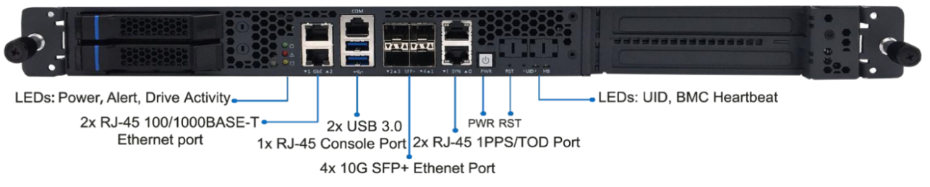
IO Interface | 2 x RJ-45 100/ 1000BASE-T Ethernet port
 | 4 x 10G SFP+ Ethernet port
 | 2 x RJ-45 1PPS/ TOD port
 | 1 x RJ-45 console port
 | 2 x USB 3.0
Back Interface | 1 x VGA rear
 | 1 x Power Plug
INTERNAL INTERFACE
IO Interface | 1 x USB 2.0
 | 1 x COM
 | 4 x 1PPS SMA input/ output
PCIe | 2 x PCIe x16 Gen3 single-slot FHFL interfaces, up to 110W each
Or
1 x PCIe x16 Gen3 single-slot FHFL interface, up to 250W
1 x PCIe x8 Gen3 OCP NIC v2
Storage | 2 x 2.5” hot-swappable SATA 6 Gb/s
 | 1 x onboard M.2 NVME socket, 2242 M Key
 | 1 x onboard M.2 NVME socket, 2280 M Key

FGAF Acceleration Card
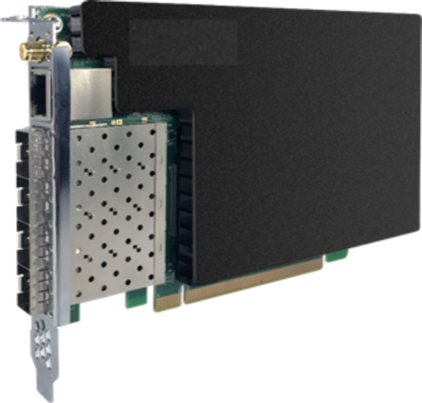
5G Virtualized Units

5G ORAN Prequel
5G Baseband Processing Acceleration
10G Ethernet 1588V2 Clock Synchronization Service

The integrated fronthaul accelerator card FGAF uses Xilinx's Zynq Ultra Scale+ MPSOC and Kintex Ultra Scale+ FPGA to realize the functions of baseband processing acceleration and data forwarding, and meets the application requirements of high bandwidth, low latency and multi-cell deployment required by the 5G BBU system. Very high integration and ease of use.

This card is a single-slot, full-height half-length (FHHL) card, using PCIeGen3x16 interface (supports bifurcation into two sets of Gen3x8 interfaces) to connect to the system, and externally supports 4 SFP+ optical ports.

The card is equipped with a high-precision clock source and clock phase-lock circuit, supports external 1588V2 and GPS input, and can provide stable clock synchronization services to the next-level network node through the SFP+ fronthaul interface.

BASEBAND PROCESSING ACCELERATION PERFORMANCE
 | Throughput Rate | Delay
LDPC Encoding | 17.8 Gbps | 14μs
LDPC Decoding | 8.1 Gbps | 16μs

FRONTHAUL DATA FORWARDING PERFORMANCE
 | Downlink Rate | Uplink Rate | Remarks
Single optical port rate | 10 Gbps | 10 Gbps | Full package mode, 4 concurrent ports
Single optical port rate | 9 Gbps | 9 Gbps | Burst32, large and small packet interval mode, 4 concurrent ports

CLOCK SYNCHRONIZATION PERFORMANCE
Support Standard | Index | Uplink Rate
Grand master | Support clock synchronization of 128 nodes | Number of Slavers
SyncE G.8262 | All 4 interfaces support
Keep ability | 1.5μs over 8 Hours | Choose high stability OCXO

SINGLE BOARD FRAME
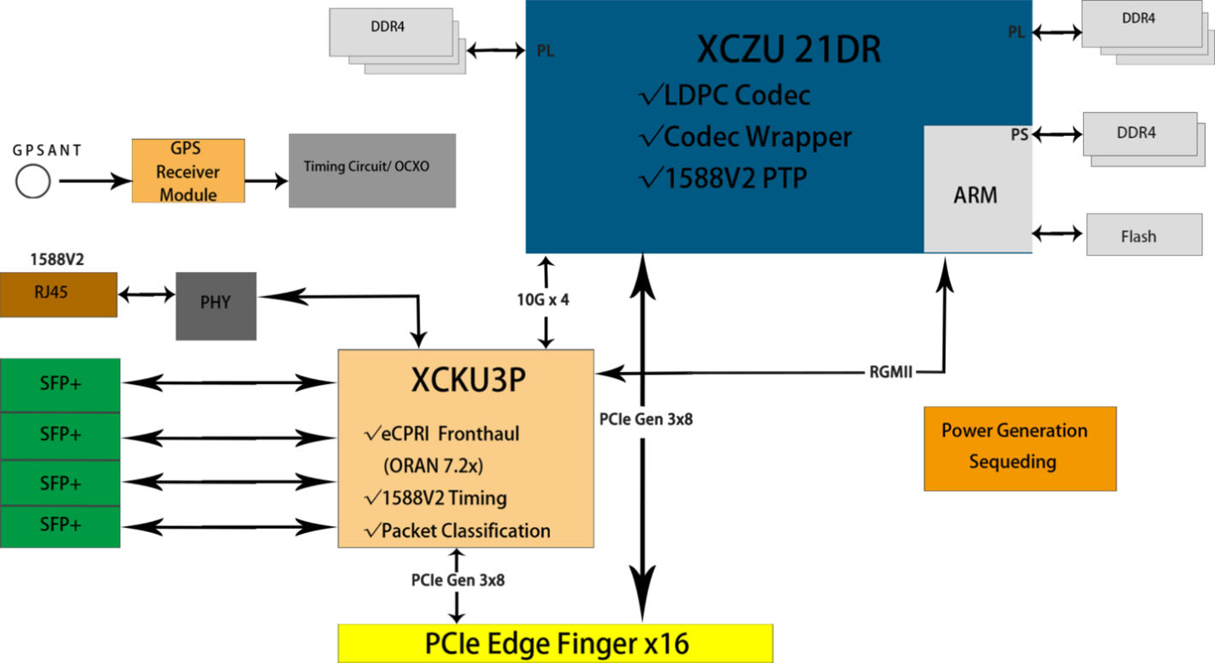

SINGLE BOARD SPECIFICATIONS
Physical layer acceleration | LDPC codec | Codec encapsulation logic, supports CRC, rate matching and de-rate matching
Fronthaul | 4x10G eCPRI  Supports 1588V2 | Data aggregation | Data cache | Package classification management
Clock circuit | Onboard OCXO, high-precision phase-locked loop synchronization circuit | Onboard GPS receiver module | Supports external 1588V2 input

CHIPSET SPECIFICATIONS
Chip Model | Xilinx | Zynq Ultra Scale Plus RFSoC | XCZU21DR
 | Xilinx | Kintex Ultra Scale+ | XCKU3P
System Resource | XCZU21DR | XCKU3P
 | - System Logic cells - 930K  - CLB LUT - 425K  - SDFEC -8  - DSP Slices - 4,272  - BRAM - 38.0Mb  - URAM - 22.5Mb | - System Logic cells - 365K  - CLB LUT - 163K  - DSP Slices - 1,368  - BRAM - 12.7Mb  - URAM - 13.5Mb  - GTY Transceivers - 16
Structure Size | Full-height, half-length (FHHL)  x16 PCIe form factor  W x H x D: 169.6 x 110.6 mm x 18.6 mm | 6.68 x 4.35 x 0.73 in
PCIe Interface | PCIe Gen3 x16 interface bifurcated to two PCIe Gen3 x8
Onboard RAM Resources | - 2xBanks of 512M x 48 –PL  - 1xBank of 512Mx 32 –PS  - Total Capacity 6GB in PL  - Total Capacity 2GB in PS | /
Onboard FLASH Resources | 1Gb SPI FLASH NOR SLC | 256Mb SPI FLASH NOR SLC
Network Interface | 4 SFP+ optical ports
Cooling Method | Module with cooling teeth, cooling through internal air ducts in the case
Single Board Management | - Single board power-up sequence management and hot reset and shutdown functions  - Supports local software upgrade  - JTAG daisy-chaining design to support burning and debugging of two devices  - On-board RS232 debug port  - On-board Ethernet debug port
Single Board Working Temperature | 0 ℃ ~ +80 ℃ | +32 °F ~ +176 °F
Single Board Power Consumption | < 35W
Single Board Clock Synchronization Mode | - Supports external GPS antenna for GPS synchronization  - Supports 1588V2 time information input via external Ethernet RJ45  - Optional high stability crystal oscillator for local clock keeping within 8 hours with time accuracy deviation less than ±1.5μs

Contact Us
www.btiwireless.com
sales@btiwireless.com

