CP980I
LTE Outdoor Industrial CPE

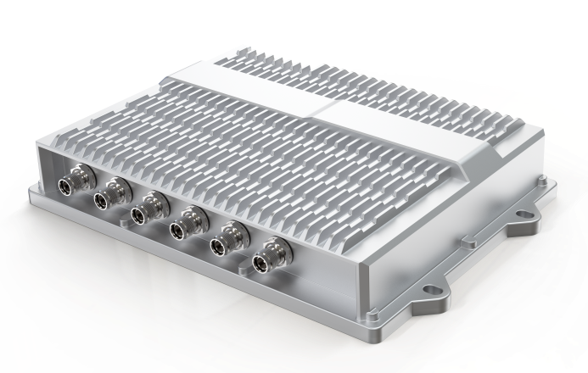
TR069
IP67
3GPP Release 14 CAT16 DL
Wi-Fi 6 (802.11ax)

The CP980I outdoor CPE from BTI WIRELESS provides LTE service in a ruggedized form factor. With an operating temperature range of -40 to +70 degree Celsius endurance, this product offers industrial-grade environmental qualifications while providing higher speeds data services for video and other bandwidth-intensive applications.

The CP980I has very strong anti-vibration ability, which qualifies it for extreme industrial environments and ideally suited for rail, transportation, mining, oil and gas, manufacturing, and other outdoor applications. The device can support multi-bands for LTE and can provide accurate real-time location information. The built-in GNSS receiver supports GPS, GLONASS, BEIDOU and Galileo constellations.

CELLULAR SPECIFICATIONS
Category | 3GPP Release 14 CAT16 DL
Peak Throughput | DL: 1Gbps (CAT16)  UL: 150Mbps (CAT13)
Frequency Bands | LTE Bands | LTE-FDD：  B1/B2/B3/B4/B5/B7/B8/B12/B13/B14/B17/B18/B19/ B20/B25/B26/B28/B29/ B30/B32/B66  LTE-TDD：  B38/B39/B40/B41/B42/B43/B46(LAA)/B48(CBRS)
Frequency Bands | WCDMA | B1/B2/B3/B4/B5/B6/B8/B19
Carrier Aggregation and MIMO | DL: 5CA intra or inter band/4x4MIMO/256QAM  UL: 2CA intra band (CA_3C, CA_41C)/64QAM
Tx / Rx | 1Tx / 4Rx
Transmit Power | Power Class 3 (23±2dBm)
Wi-Fi | Supports 2.4GHz/5GHz dual band  IEEE802.11 b/g/n/ac/ax Wi-Fi

TOPOLOGY
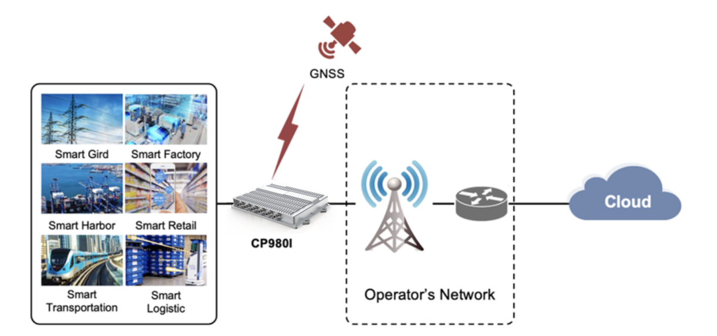

HARDWARE SPECIFICATIONS
Chipset | Qualcomm IPQ6010 + SDX24
Fixed Interfaces | 1 x M12 for Power supply  1 x M12 for 10/100/1000Mbps compatible GE port  1 x M12 for 2.5GHz GE port  1 x M12 for RS232 + 2 x DI + 2 x DO  1 x M12 for RS485  2 x Nano SIM Slot (4FF, Dual SIM Single Active)
Antenna Ports | 3 x TNC female for LTE antennas  1 x TNC female for LTE&GNSS antenna  2 x TNC female for Wi-Fi antennas
GNSS | Supports GPS, GLONESS, BEIDOU and Galileo
LED Indicator | 1 x Power indicator  1 x Network status indicator  1 x RSSI indicator
Button | 1 x Reboot or Restore Button
Power Consumption | < 18W
Operating Voltage | 9V ~ 36V DC
Dimensions | 250 x 171 x 61mm | 9.84 x 6.73 x 2.40 in
Weight | ≈ 2 kg | 4.41 lbs

SOFTWARE SPECIFICATIONS
WAN | Multiple APN support, maximum 4
WAN | Multi PDN
WAN | IPv4/IPv6 dual stack
LAN | VLAN 802.1Q
LAN | DHCP V4/V6
LAN | DNS and DNS proxy
LAN | DMZ
LAN | UPNP
LAN | ALG
LAN | ARP/ICMP/IGMP
LAN | MAC address Filtering
Device Management | Version management: Image Checksum
Device Management | HTTP/FTP Auto Upgrade
Device Management | TR069 | Upload/ Download the ACS specified file
Device Management | TR069 | Download the configuration file
Device Management | TR069 | Configure & queries parameters
Device Management | TR069 | Remote upgrade
Device Management | TR069 | Remote debugging operations
Device Management | TR069 | Cycle monitor
Device Management | SNMP
Device Management | WebGUI/ CLI | Different level of user login priority and different limitation and display
Device Management | WebGUI/ CLI | Encryption backup current settings and restore the backup settings
Device Management | WebGUI/ CLI | Export current diagnosis results and operation logs
Device Management | WebGUI/ CLI | Statistics of LAN link status, transmit and receive traffic and up time
Device Management | Diagnostics
Device Management | USIM PIN management and card authentication
Device Management | USIM activation
Device Management | NAT/Bridge mode
Device Management | Port mirror/Port forwarding
VPN and Routing | Static Routing
VPN and Routing | IPsec
VPN and Routing | PPTP
VPN and Routing | GRE Tunnel
VPN and Routing | L2TP v2/v3
Security | Firewall
Security | MAC address filtering
Security | IP address filtering
Security | URL filtering
Security | Access control
Security | HTTPS login from WAN
Security | Dos attack protection
Security | 2 level of user authority

ENVIRONMENT SPECIFICATIONS
Temperature | Operating | -40 ℃ ~ +70 ℃ | -40 °F ~ +158 °F
Temperature | Storage | -40 ℃ ~ +85 ℃ | -40 °F ~ +185 °F
Humidity | Operating | 10 ~ 90%
Humidity | Storage | 5 ~ 95%

Contact Us
www.btiwireless.com
sales@btiwireless.com

