CP880I
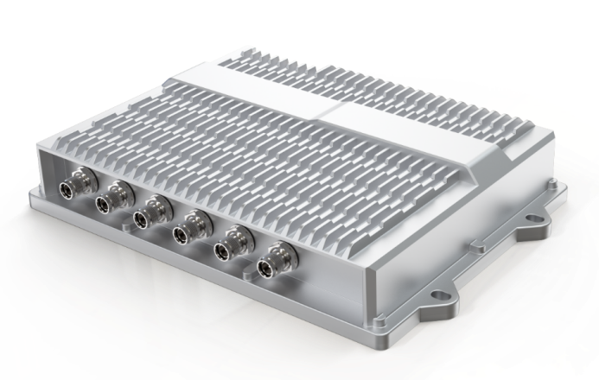
LTE Outdoor Industrial CPE

CAT12
IP67
IEEE802.11a/b/g/n/ac Wi-Fi

The CP880I from BTI WIRELESS is an industrial CPE, providing sustainable and durable LTE service with higher data transmission speed for video and other bandwidth-intensive applications. The industrial CP880I CPE has a special anti-vibration feature, which qualifies it for extreme environments where it can work in a temperature range from -40 °C to 70 °C. It is an ideal industrial CPE for outdoor scenarios with crucial industrial requirements, such as Railway, Transportation, Manufacturing, Mining, Oil and Gas, etc.

The CP880I is integrated with multiple LTE-A modules, which make it possible to connect with multiple bands of private LTE, including uncommon frequencies. The CP880I also provides accurate, real-time location information via the built-in GNSS receiver, able to collaborate with GPS, GLONASS, BEIDOU and Galileo constellations.

CELLULAR SPECIFICATIONS
Peak Throughput | FDD: DL 400 Mbps UL 150 Mbps  TDD: DL 280 Mbps UL 30 Mbps
LTE Bands | CP880I-A | Band 1/3
LTE Bands | CP880I-B | Band 2/4/5/8/12/13/14/25/26/38/41/42/43/48/53/66
LTE Bands | CP880I-C | Band 46/240
Carrier Aggregation and MIMO | DL: 2 CA Intra- or Inter-band, 2 x 2 MIMO, 256 QAM  UL: 2 CA or 2 x 2 MIMO, 64 QAM
Tx / Rx | 2Tx / 2Rx
EIRP | < 23dBm (Include antenna)

TOPOLOGY
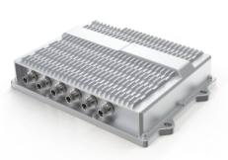
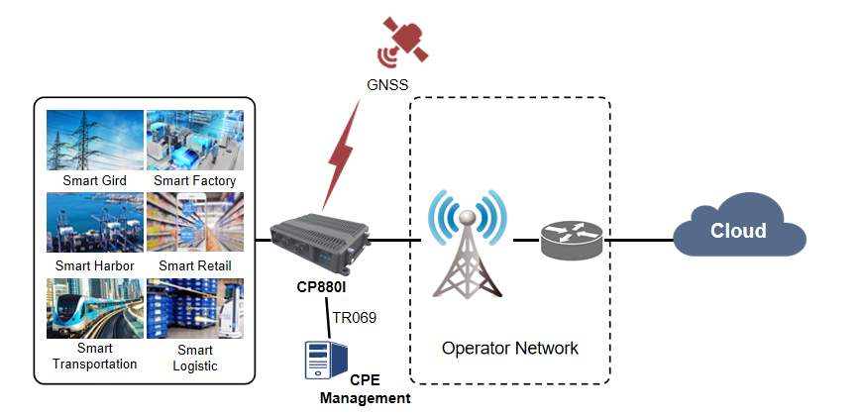

HARDWARE SPECIFICATIONS
Fixed Interfaces | 1 x M12 for Power  2 x M12 for 10/100/1000 Mbps compatible GE  1 x M12 for RS232 + 2 x DI + 2 x DO  1 x M12 for RS485  2 x Nano SIM slot (4FF, Dual SIM Single Standby)
Antenna Ports | 2 x TNC female for cellular antennas  1 x TNC female for GNSS antenna  2 x TNC female for Wi-Fi antennas
GNSS | Supports GPS, GLONESS, BEIDOU and Galileo Constellation  Acquisition sensitivity: 148dBm (GPS at cold start)  Tracking sensitivity: 167dBm (GPS in continuous mode)
LED Indicator | 1 x PWR indicates Power Status  1 x NET indicates Network Status  1 x RSSI LED indicates SIM/Signal status
Button | 1 x Reboot or Restore Button
Power Consumption | < 13W
Power supply | 9~36V DC
Dimensions | 250 x 171 x 61mm | 9.84 x 6.73 x 2.40 in
Weight | ≈ 2 kg | 4.4 lbs
EMC Compliance | EN55032 (CE&RE) Class B  IEC61000-4-2(ESD) Level 4  IEC61000-4-3 (RS) Level 2  IEC61000-4-4 (EFT) Level 4  IEC61000-4-5 (Surge) Level 3  IEC61000-4-6 (CS) Level 2
Environment Compliance | Cold: IEC60068-2-1  Dry heat: IEC 60068-2-2  Damp heat cyclic: IEC 60068-2-30  Change of temperature: IEC 60068-2-14  Protection Rating: EN60529, IP67  Shock and Vibration: EN50155  Free Fall: IEC60068-2-32 (1 meter height with package)  Salt Mist: IEC 68-2-11, 72H
WAN | Multiple APN support, maximum 4  IP pass-through  IPv4/IPv6 dual stack
LAN | VLAN 802.1Q  DHCP Server  DNS and DNS proxy  DMZ  Multicast/Multicast Proxy
Protocol | Routing: static routing
Device Management | TR069  SNMP V2  Web UI  Software upgrade via WEB/ TR069/ FOTA  USIM PIN management
Routing Mode | Route mode  Bridge mode  NAT mode  Static route  Port mirror and port forwarding  IPv4/ IPv6 dual stack
VPN | PPTP  GRE tunnel (L2/L3)  L2TPv2 and L2TPv3
Security | Firewall  MAC address filtering  IP address filtering  URL filtering  Access control  HTTPS login from WAN  Dos attack protection  2 level of user authority
Reliability | Watchdog for automatic recovery  Auto-rollback to previous version when upgrade fails  Dual WAN for link backup

ENVIRONMENT SPECIFICATIONS
Temperature | Operating | -40 ℃ ~ +70 ℃ | -40 °F ~ +158 °F
Temperature | Storage | -40 ℃ ~ +85 ℃ | -40 °F ~ +185 °F
Humidity | 5 ~ 95% non-condensing

Contact Us
www.btiwireless.com
sales@btiwireless.com

