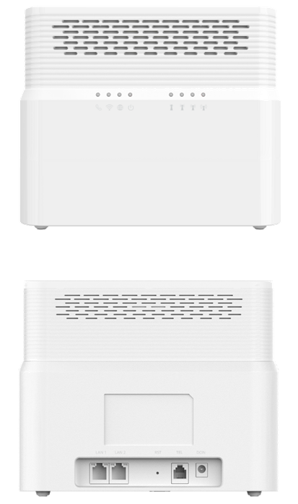

CP860

LTE Indoor CPE

3GPP Release 12

CAT12

802.11a/b/g/n/ac

VoIP or VoLTE

The CP860 from BTI WIRELESS is a premium indoor LTE CPE, designed for 802.11a/b/g/n/ac dual band Wi-Fi access. The product provides optimized high throughput data and a wide area coverage network for residential, commercial and enterprise users, supporting multiple services. Customers enjoy reliable dual-band Wi-Fi AP functions, broadband access and hot-spot Wi-Fi connections with the CP860.

|  |  |  |  |  |
| --- | --- | --- | --- | --- |
| **RF SPECIFICATIONS** | | | | |
| **Support Bands** | **Option 1** | | LTE: B1/3/7/8/20/38/41/42/43/48 | |
| **Option 2** | | LTE: B7/38/41 | |
| **CA** | | | DL Inter/Intra 2CA/3CA/4CA  UL Inter/Intra 2CA | |
| **MIMO** | | | DL 2CA (4 x 4 MIMO 64 QAM)  DL 4CA (2 x 2 MIMO 256 QAM)  UL 2CA (2 x 2 MIMO 64 QAM) | |
| **Output Power**@25oC/ 77oF | | | 23 ± 2dBm | |
| **LTE Antenna** | | | 4 built-in antennas | |
| **LTE Antenna Gain** | | | 700 MHz ~ 1 GHz | 3 dBi |
| 1.5 GHz ~ 2.7 GHz | 5 dBi |
| 3.4 GHz ~ 3.8 GHz | 5 dBi |
| **Wi-Fi** | | **Wi-Fi frequency** | 2.4 GHz/ 5GHz | |
| **Wi-Fi antenna** | Built-in high-gain Wi-Fi antenna | |
| **Wi-Fi output power** | 19dBm @2.4GHz  16dBm @5GHz | |
| **Wi-Fi channel BW** | 20 MHz & 40 MHz & 80 MHz | |
| **Wi-Fi antenna gain** | 2.4 GHz: 3 dBi  5G Hz: 3 dBi | |

|  |  |
| --- | --- |
| **HARDWARE SPECIFICATIONS** | |
| **LTE Standard** | 3GPP Release 12, CAT 12 |
| **Flash** | 2 GB |
| **RAM** | 2 GB |
| **Ethernet LAN Port** | 2 Gb RJ45 LAN port  10/100/1000M auto-sensing, auto-MDI/ MDIX |
| **Voice POTS Port** | 1 RJ11 |
| **LED** | 8 LED indicators (PWR, Wi-Fi, TEL, NET, RF Signal x 4) |
| **SIM** | 1 USIM/ SIM (3FF) |
| **Reset/Reboot Button** | Tact switch |
| **LTE Antenna** | 4 built-in antennas |
| **Dimensions** | 204.5 mm x 169 mm x 60 mm | 8.05 in x 6.65 in x 2.36 in |
| **Weight** | < 500 g | 1.1 lbs |
| **Power Consumption** | < 12W |
| **Power Supply** | AC 100 ~ 240V  DC 12V 2A |

|  |  |  |
| --- | --- | --- |
| **ENVIRONMENT SPECIFICATIONS** | | |
| **Temperature** | Operating | -10 ℃ ~ 55 ℃ | 14 °F ~ 113 °F |
| Storage | -40 ℃ ~ 85 ℃ | -40 °F ~ 185 °F |
| **Humidity** | Operating | 5 ~ 95% |
| Storage | 5 ~ 95% |

|  |
| --- |
| **TOPOLOGY** |
|  |

|  |  |
| --- | --- |
| **SOFTWARE SPECIFICATIONS** | |
| **Peak Throughput** | TDD DL 560 Mbps UL 30 Mbps |
| FDD DL 800 Mbps UL 150 Mbps |
| **Operation Mode** | NAT mode |
| Route Mode |
| Bridge Mode |
| **Device Management** | TR069 |
| SNMP |
| WebUI |
| Software Upgrade - FOTA |
| **Network Protocols and Features** | Multi-APN |
| NAT/NATP |
| SNTP/NITZ |
| Static Routing |
| Virtual server and DMZ |
| DNS relay and DDNS |
| IGMP snooping and IGMP proxy |
| DHCP server |
| IPV4/IPv6 Dual Stack |
| UPnP |
| Parents control |
| **VPN** | IPsec |
| L2TP over IPsec |
| GRE over IPsec |
| GRE L2/L3 |
| PPTP |
| L2TP V2/V3 |
| **Security and Firewall** | Firewall |
| MAC address filtering |
| IP address filtering |
| URL filtering |
| DDOS |
| **VoIP/ VoLTE Functions** | Call waiting |
| Call hold/ resume |
| Call forward on busy/ no answer |
| Call transfer blind transfer/ attended transfer/ early attended transfer |
| 3-way conferencing |
| Caller ID display/ blocking |
| DTMF |
| FAX/ modem |
| **Wi-Fi Functions** | Hide SSID broadcasting |
| Encryption: WPA-PSK (TKIP), WPA-PSK (AES), WPA2-PSK (TKIP),  WPA2-PSK (AES) |
| Maximum users: 64 |
| AP Isolation |
| Guest network |

Contact Us

[www.btiwireless.com](http://www.btiwireless.com)

[sales@btiwireless.com](mailto:sales@btiwireless.com)