## 3ddb78a0551a3ad26751eb99296fc05

**IP65 IP68**(optiona)

* **Characteristic**

**UL62368-1**



**TPTC004**

## 

**IEC62368-1**

# **Applications**

## -Full Range AC input (up to 305vac)

## -With active PFC function

## -Efficiency up to 95%

## -Fan free design, natural-cooling

## - -55 ~ +65 ℃ working temperature range

## -Aluminum casing, filled with thermal conductive adhesive

## -IP65protection grade, and IP68 protection grade can be selected

## -Lightning surge capacity up to 6kV

## -Vibration test：10G

## -Can work at an altitude of 5000m (Note 7)

## -Protection: short circuit / overload / over-voltage / over temperature

## -6-year warranty

* **Description**

## -Outdoor communication equipment

## -Outdoor electronic billboards and billboards

-Oil plant or pit area equipment

# **Global transaction item identifying code**

Hep-480 is a 480W industrial AC to DC power supply, which is characterized by its excellent ability to be used in harsh environments with high humidity, high dust, oil and high vibration. The whole series are made of aluminum shell, and the body is filled with thermal conductive silica gel. Due to the advanced technology, the working efficiency could up to 95%, making the HEP-480 operate between -55 ℃ and +65 ℃ ambient temperature under natural air cooling.

# **Model Code**

## Function Mode Option

Output Voltage

**HEP - 480 - 24 A**

Output Power

Series

## Standard Type: the output voltage and output current can be adjusted by an internal potentiometer

## Optional Type: fixed output voltage and current values

{

Electrical specifications

|  |  |  |  |  |  |
| --- | --- | --- | --- | --- | --- |
| Model | | **HEP-480-24** | **HEP-480-36** | **HEP-480-48** | **HEP-480-54** |
| Output | DC voltage | 24V | 36V | 48V | 54V |
| Rated current | 20A | 13.3A | 10A | 8.9A |
| Rated power | 480W | 478.8W | 480W | 480.6W |
| Ripple and noise (max) Remark 2 | 200mVp-p | 250mVp-p | 250mVp-p | 350mVp-p |
| Voltage adjustment range (Remark 5) | A type only((via internal potentiometer) | | | |
| 20.4 ~ 25.2V | 30.6 ~ 37.8V | 40.8 ~ 50.4V | 45.9 ~ 56.7V |
| Current adjustment range | A type only((via internal potentiometer) | | | |
| 10 ~ 20A | 6.6 ~ 13.3A | 5 ~ 10A | 4.4 ~ 8.9A |
| Voltage accuracy (Remark 3) | ±1.0% | ±1.0% | ±1.0% | ±1.0% |
| Linear adjustment rate | ±0.5% | ±0.5% | ±0.5% | ±0.5% |
| Load adjustment rate | ±0.5% | ±0.5% | ±0.5% | ±0.5% |
| Start and rise time (remark 4) | 500ms,80ms/115VAC/230VAC | | | |
| Hold time (Typ.) | 16ms 230VAC /115VAC | | | |
| Input | Voltage range (Remark 5) | 85 ~ 264VAC(working in 277VAC) 120 ~ 370VDC(working in 390VDC) | | | |
| Frequency range | 47 ~ 63Hz | | | |
| PF(Typ.) | PF≧0.98/115VAC, PF≧0.97/230VAC, PF≧0.95/277VAC(At full load) | | | |
| Efficiency(Typ.) | 94% | 95% | 94.5% | 95% |
| AC current(Typ.) | 5A / 115VAC 2.45A / 230VAC 2A/277VAC | | | |
| Surge current(Typ.) | cold boot35A/230VAC | | | |
| Leakage current | <0.75mA / 277VAC | | | |
| Protection | Over current | 105%~ 125% | | | |
| Constant current limit, which can be recovered automatically after the abnormal load conditions are removed | | | |
| Short circuit | Constant current limit, which can be recovered automatically after the abnormal load conditions are removed | | | |
| Over voltage | 27 ~ 33V | 40 ~ 50V | 53 ~ 63V | 60 ~ 70V |
| Turn off output voltage and resume after restart | | | |
| Over temperature | Turn off output voltage and resume after restart | | | |
| Environment | Operating temperature | -55 ~ +65℃ (Please refer to "Derating Curve") | | | |
| Working humidity | 20 ~ 95% RH, non-condensing | | | |
| Storage temperature, humidity | -60 ~ +80℃, 10 ~ 95% RH | | | |
| Temperature coefficient | ±0.02%/℃ (0 ~ 60℃) | | | |
| vibration resistance | 20 ~ 500Hz, 10G 12 min/cycle, 72 min each X, Y, Z | | | |
| Safety regulations and electromagnetic compatibility | safety norm | UL62368-1,IEC62368-1, IP65 (orHEP-480 BlankIP68), EAC TP TC 004 approved ;  Design reference BS EN/EN62368-1 | | | |
| pressure resistance | I/P-O/P:3.75KVAC I/P-FG:2KVAC O/P-FG:1.5KVAC | | | |
| Insulation impedance | I/P-O/P, I/P-FG, O/P-FG:100M Ohms/500VDC/ 25℃/ 70% RH | | | |
| electromagnetic compatibility emission | Conforms to BS EN/EN55032 (CISPR32) Class B, BS EN/EN61000-3-2,-3, EAC TP TC 020 | | | |
| Electromagnetic compatibility immunity | Compliant with BS EN/EN61000-4-2,3,4,5,6,8,11, BS EN/EN55024,Light Industrial Standard (Surge 6KV）, EAC TP TC 020 | | | |
| Others | MTBF | 1036.8K hrs min. Telcordia SR-332 (Bellcore) ; 89.8Khrs min. MIL-HDBK-217F (25℃) | | | |
| Dimension | 262*125*43.8mm (L*W*H) | | | |
| Package | 2.8Kg; 4pcs/11.5Kg/0.58CUFT | | | |
| Remark | 1. All specifications are measured at 230VAC input, rated load, and 25°C ambient temperature, unless otherwise noted. 2. Ripple and noise measurement method: Use a 12" twisted pair cable, while terminating with 0.1uf and 47uf capacitors in parallel, and measure at 20MHZ bandwidth. 3. Accuracy: contains setting error, linearity adjustment rate and load adjustment rate. 4. Start-up time is measured at cold start-up, frequent switching on and off may increase the start-up time. 5. Reduced output is required for low input voltages, please refer to the "Static Curve" section for details. 6. The power supply is considered as a component to be used in conjunction with the end device, and since EMC is affected by the complete unit, the end device manufacturer needs to re-check EMC for the complete unit. 7. IP68 means that it is water resistant and can be placed underwater at a depth of 1 meter for one month. 8. When the operating altitude is higher than 2000m (6500ft), the operating loop temperature needs to be adjusted down by 3.5℃/1000m for fanless models and 5℃/1000m for models with fans. | | | | |

PFC oscillation frequency:45KHz

PWM oscillation frequency:55KHz

Diagram

### PFC : 45KHz PWM: 55KHz

I/P

FG

Electromagnetic filter circuit &rectifier circuit

PFC

Circuit

PFC

control circuit

Overload

protection circuit

Over temperature protection circuit

Switching

Circuit

PWM

control circuit

Rectifier/

Filter Circuit

+V

-V

Overload

protection

Detection circuit

Over voltage protection

Circuitt

Static characteristic curve

## 

Derating curve

100

80

Load(%)

60

40

20

110VAC

230VAC

100

90

80

Load(%)

70

60

50

40

-55 -25 -10 0 15 30 50 60 65 70

## Environment Temperature (℃)

(水平)

90 110 125 135 145 155 165 175 180 200 230 305

Input Voltage**(V) 60Hz**

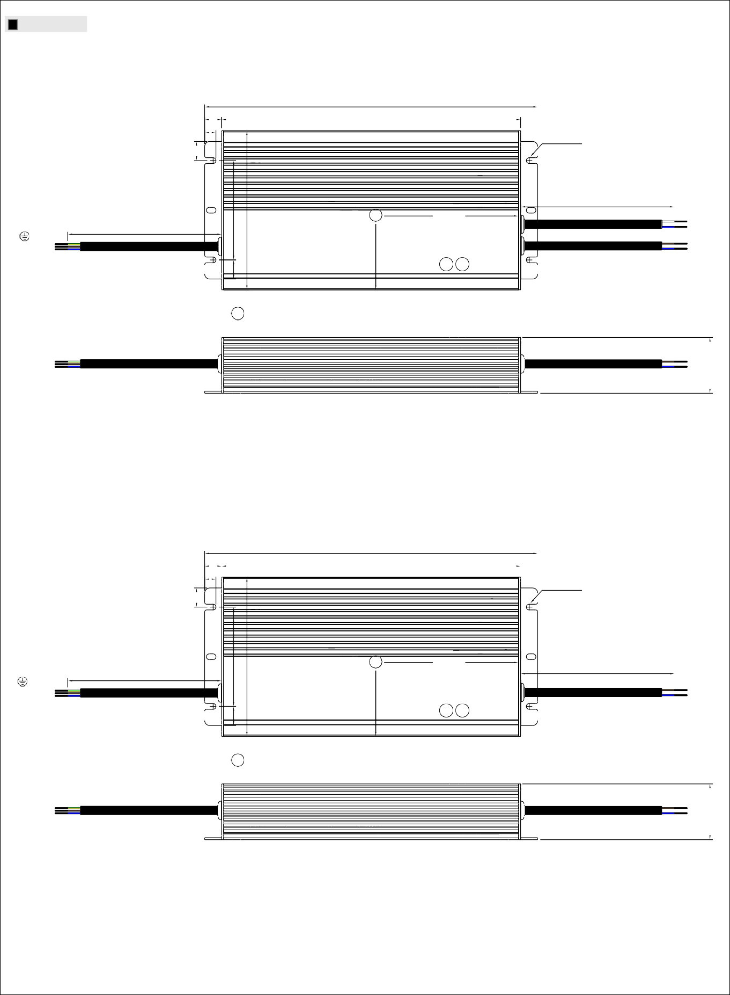

### 机壳型号:251 单位:mm

Mechanism size

※**A Type: Standard Type**

### 24V,36V

262

13.4 235.2

8.9

ψ4.5×4PL

15

tc 113.8

78

125

58

300±20

Vo+(brown)

FG (green) AC/L(brown)

300±20

Vo Io

SJOW 17AWG×2C / H05RN-F 1.0mm2

Vo-(blue) Vo+(brown)

AC/N(blue)

15

SJOW 17AWG×3C / H05RN-F 3G 1.0mm2

ADJ. ADJ.

SJOW 17AWG×2C / H05RN-F 1.0mm2

Vo-(blue)

‧tc : 机壳最高温度

43.8

### Other

262

13.4 235.2

8.9

ψ4.5×4PL

15

FG (green) AC/L(brown)

78

125

300±20

tc 113.8

Vo Io

58

300±20

Vo+(brown)

AC/N(blue)

15

SJOW 17AWG×3C / H05RN-F 3G 1.0mm2

ADJ. ADJ.

SJOW 17AWG×2C / H05RN-F 1.0mm2

Vo-(blue)

‧tc : Maximum Case Temperature

43.8

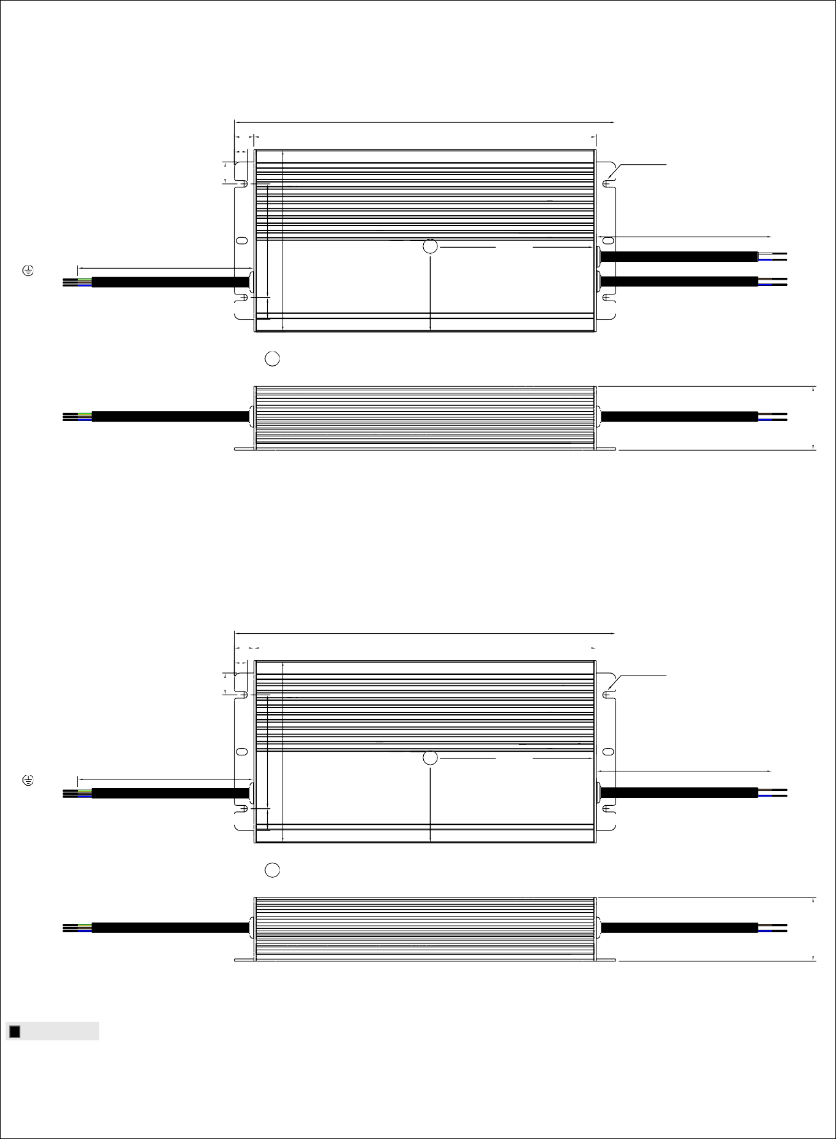

### ※ Blank Type **(**optional**)**

24V,36V

262

13.4 235.2

8.9

ψ4.5×4PL

15

tc 113.8

78

125

58

300±20

Vo+(brown)

FG (green) AC/L(brown)

AC/N(blue) SJOW 17AWG

300±20

×3C / H05RN-F 3G 1.0mm2

15

SJOW 17AWG×2C / H05RN-F 1.0mm2 SJOW 17AWG×2C / H05RN-F 1.0mm2

Vo-(blue) Vo+(brown) Vo-(blue)

‧tc : Maximum Case Temperature

43.8

### Other

262

13.4 235.2

8.9

ψ4.5×4PL

15

FG (green) AC/L(brown) AC/N(blue)

SJOW 17AWG

300±20

×3C / H05RN-F 3G 1.0mm2

15

78

125

tc 113.8

300±20

SJOW 17AWG×2C / H05RN-F 1.0mm2

Vo+(brown) Vo-(blut)

‧tc : Maximum Case Temperature

58

43.8