sCELL-RU4460

EXTRA POWER RRU

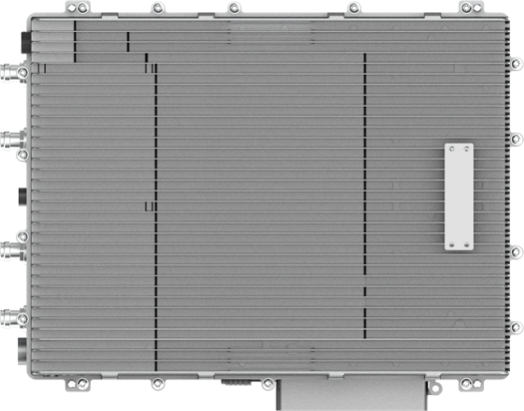

4T4R Digital Radios

40W (46dBm) Output Power

Passive Cooling

IP67 Outdoor Rated

The RU4460 is a digital transport platform supporting cellular technologies on fiber optic cable using the CPRI protocol. The power amplifier technology adopts DPD (Digital Pre-Distortion), allowing for a significant improvement in power consumption compared with analogue technology. This platform is ideal for underground tunnels & outdoor coverage deployments of cellular services.

|  |
| --- |
| **KEY FEATURES** |
| * Supports 2T2R & 4T4R * Up to 40W (46dBm) Output Power * Supports Cascading * Supports Sub-6GHz TDD and External Alarm |

|  |  |
| --- | --- |
| **TECHNICAL SPECIFICATIONS** | |
| **SYSTEM** | |
| **Bandwidth per Channel (Downlink & Uplink)** | ≤ 100 MHz (Contiguous) |
| **Digital Bandwidth per Channel (Downlink & Uplink)** | 3/5/10/20 MHz |
| **Redundancy** | Cascading |

|  |  |  |  |  |
| --- | --- | --- | --- | --- |
| **SUPPORTED BANDS** | | | | |
| **Band Frequency** | **3GPP Band** | **Downlink Frequency** | **Uplink Frequency** | **Max Bandwidth** |
| 2300MHz TDD | 40 | 2300-2400 | 2300-2400 | 100 |
| 2500MHz TDD | 41 | 2496-2690 | 2496-2690 | 100 |
| 2600MHz TDD | 38 | 2570-2620 | 2570-2620 | 50 |
| 3500MHz TDD | 42 | 3400-3600 | 3400-3600 | 100 |
| 3600MHz TDD | 43 | 3600-3800 | 3600-3800 | 100 |
| 2100 MHz FDD | 1 | 2110-2170 | 1920-1980 | 70 |
| 1800 MHz FDD | 3 | 1805-1880 | 1710-1785 | 75 |
| 2600 MHz FDD | 7 | 2620-2690 | 2500-2570 | 70 |
| *\* More bands will be supported in the roadmap* | | | | |

|  |  |
| --- | --- |
| **INTERFACES** | |
| **Antenna Interface (All bands)** | 4.3-10 Female |
| **Optical Connector Type** | SFP+, Standard LC |
| **Optical Transmission Rate** | 9.8304GB/s |
| **Optical Fiber Length** | 1.4km / 10km / 30km  0.87mi / 6.21mi / 18.64mi |
| **Dry Contact** | 2 Inputs & 2 Outputs, NO and NC Mode |
| **Maintenance Interface** | Ethernet RJ45 |

|  |  |
| --- | --- |
| **ELECTRICAL** | |
| **Complies with** | 3GPP TS36.106 | 3GPP TS25.106 |
| **EMC** | EN 301489-1 / -50, EN 55032 |
| **Safety** | EN 60950-1, EN 60950-22, EN 62368-1, EN 50385 |
| **Maximum Power Consumption** | 700W |
| **Power Supply** | 48VDC ± 20% |

|  |  |
| --- | --- |
| **ENVIRONMENTAL** | |
| **Mean Time Between Failure (MTBF)** | > 100,000 hours |
| **Operating Temperature** | -40 °C ~ +55 °C | -40 °F ~ +131 °F |
| **Humidity** | 5% to 100% (Non-Condensing) |
| **Cooling** | Passive |
| **Installation** | Wall or Pole |
| **Ingress Protection Rating** | IP67 (Outdoor) |
| **Complies with** | EN 300019-1-1, EN 300019-1-2, EN 300019-1-4 |

|  |  |
| --- | --- |
| **MECHANICAL** | |
| **Size (Width x Height x Depth)** | 500 x 380 x 142 mm | 19.7 x 14.96 x 5.59 in |
| **Weight** | 27.9 kg | 61.5 lbs |

Contact Us

[www.btiwireless.com](http://www.btiwireless.com)

[sales@btiwireless.com](mailto:sales@btiwireless.com)