CPX80P
5G Sub-6 Outdoor CPE
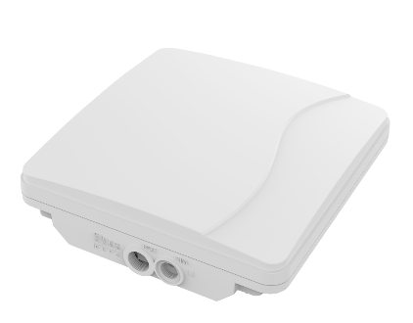

CAT20
5GNR/LTE/WCDMA
Qualcomm SDX62
POE
IP67

The CPX80P from BTI WIRELESS is an Outdoor 5G CPE, supporting various 4G/5G spectrums and provides ultra-high speed experience. It has built-in high-gain directional antennas to expand the signal coverage. The CPX80P ensures quality of wireless communication for various outdoor environments in an IP67 enclosure, protecting it from water, vibration, shock, and lightning.

KEY FEATURES
- Qualcomm SDX62 chip solution
- 5G NR and LTE-A CAT20 dual mode
- Supports both SA and NSA
- Worldwide sub-6 5G and LTE-A coverage
- Supports POE power supply, comply to 802.3at
- Powerful software features, supporting all router features
- Supports Web, TR069 and SNMP based device management
- IP67 water and dust proof
- Built-in high-gain antennas

SYSTEM ELEMENTS
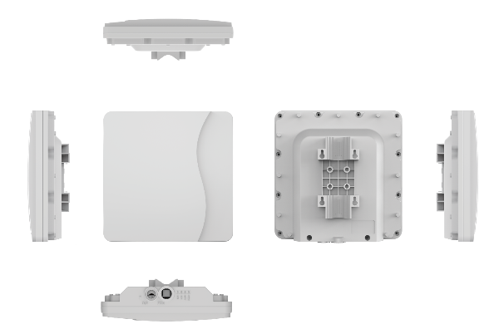

HARDWARE SPECIFICATIONS
Technical Standard | WAN | 5G NR/LTE/WCDMA
 | LAN | IEEE 802.3/802.3u/802.3bz
Cellular Bands  (CPX80P – A2 ) | 5G NR | n1/n3/n5/n7/n8/n20/n28/n38/n40/n41/n75/n76/n77/n78
 | LTE | B1/B3/B5/B7/B8/B20/B28/B32/B38/B40/B41/B42/B43
 | WCDMA | B1/B5/B8
Cellular Bands  (CPX80P – B2 ) | 5G NR | n2/n5/n7/n12/n13/n14/n25/n26/n29/n30/n38/n41/n48/n66/n70/n71/n77/n78
 | LTE | B2/B4/B5/B7/B12/B13/B14/B17/B25/B26/B29/B30/B38/B41/B42/B43/B46 (LAA) /B48/B66/B71
Cellular Bands  (CPX80P – B2H ) | 5G NR | n48/n77/n78
 | LTE | B42/B43/B48
External Port | 1 x RJ45 2.5Gigabit Ethernet port  1 x SIM Slot (2FF)
Antenna | CPX80P – A2：4 cellular antenna interfaces  CPX80P – B2：4 cellular antenna interfaces  CPX80P – B2H：4 cellular antenna interfaces
LED Indicators | 1 x Power indicator  1 x Network status indicator  1 x Tri-color Signal strength indicators  1 x SIM status indicator
Button | 1 x reboot /restore button
Carrier Aggregation | LTE: DL 5CA and UL 2CA  NR: 2CA
Tx/Rx | CPX80P-A2 | 2Tx/4Rx (n38/n41/n77/n78) ^{①}  1Tx/4Rx (n1/n3/n5/n7/n8/n20/n28/n40/n75/n76)
 | CPX80P-B2 | 2Tx/4Rx (n38/n41/n48/n77/n78) ^{①}  1Tx/4Rx (n2/n5/n7/n12/n13/n14/n25/n26/n29/n30/n66/n70/n71)
 | CPX80P-B2H | 2Tx/4Rx (n48/n77/n78) ^{①}
Maximum Transmission Power | 5G NR Sub 6 Bands |  | Class 3 (23 dBm ±2 dB)
 | n41/n77/n78 HPUE |  | Class 2 (26 dBm +2/-3 dB) ^{②}
 | 4G LTE |  | Class 3 - 23dBm
 | B38/B41/B42 HPUE |  | Class 2 (26 dBm ±2 dB) ^{②}
 | WCDMA |  | Class 3 (23 dBm ±2 dB)
Maximum Transmit  Throughput  (CPX80P – A2/CPX80P – B2/B2H)^{③} | Downlink | 5G NR SA(Gigabit Ethernet port) | 2.4Gbps
 |  | 5G NR NSA(Gigabit Ethernet port) | 3.2Gbps
 |  | 4G LTE (Gigabit Ethernet port) | 1.6Gbps
 |  | WCDMA (Gigabit Ethernet port) | 42Mbps
 | Uplink | 5G NR SA(Gigabit Ethernet port) | 900Mbps
 |  | 5G NR NSA(Gigabit Ethernet port) | 600Mbps
 |  | 4G LTE (Gigabit Ethernet port) | 200Mbps
 |  | WCDMA (Gigabit Ethernet port) | 5.76Mbps
Power Supply | POE 24V/ 48V DC (IEEE802.3at optional)
Power Consumption | < 24W
Dimensions (Maximum) | 288 x 288 x 82 mm | 11.34 x 11.34 x 3.23 in
Weight | < 2 kg | 4.41 lbs
Humidity | 5% ~ 95% Non-condensing
Temperature | Working temperature: -30 °C ~ 60 °C | -22 °F ~ 140 °F  Storage temperature: -40 °C ~ 70 °C | -40 °F ~ 150 °F

SOFTWARE SPECIFICATIONS
Data Services | 4 x APNs
 | Multiple PDN
 | IPv4/IPv6 dual stack support
LAN | DHCPV4/ DHCPV6 server/ client
 | DNS and DNS proxy
 | DMZ
 | UPNP
 | ALG
 | IEEE 802.1Q VLAN
 | MAC address filtering
Management | Version  Management | Image checksum
 | HTTP/FTP auto-upgrade
 | TR069 | Upload/ Download the ACS specified file
 |  | Download the configuration file
 |  | Configure & queries parameters
 |  | Remote upgrade
 |  | Remote debugging operations
 |  | Cycle monitor
 | SNMP
 | WebGUI/ CLI | Different level of user login priority with various limitation and display
 |  | Encryption backup current settings and restore the backup settings
 |  | Export of current diagnosis results and operation logs
 |  | Statistics of LAN link status, transmit and receive traffic and up time
 | Diagnostics
 | USIM PIN management and card authentication
 | USIM activation
VPN & Routing | Bridge mode
 | NAT mode
 | Port mirror
 | Port forwarding
 | IPSec
 | PPTP
 | GRE tunnel
 | L2TP V2/V3
Security | Firewall
 | Mac address filtering
 | IP address filtering
 | URL filtering
 | Access control
 | HTTPS login from WAN
 | DDOS attack protection
 | Hierarchical user management

COMPLIANCE SPECIFICATIONS
Environment Compliance | Cold: IEC 60068-2-1
 | Dry heat: IEC 60068-2-2
 | Damp heat cyclic: IEC 60068-2-30
 | Change of temperature: IEC 60068-2-14
 | Shock: IEC60068-2-27
 | Free fall: IEC60068-2-32
 | Vibration: IEC60068-2-6

ANTENNA SPECIFICATIONS
CPX80P-A2/B2
617 MHz ~ 960 MHz | 6 dBi | Directional
1.7 GHz ~ 2.7 GHz | 9 dBi | Directional
3.3 GHz ~ 5 GHz | 11 dBi | Directional
CPX80P-B2H
3.3 GHz ~ 4.2 GHz | 16 dBi | Directional

^{①} UL 2 × 2 MIMO is only supported in 5G SA mode.
^{②} HPUE only supports single carrier.
^{③} Cellular data throughput is the theoretical value of the module.
Contact Us
www.btiwireless.com
sales@btiwireless.com

