MDN80I

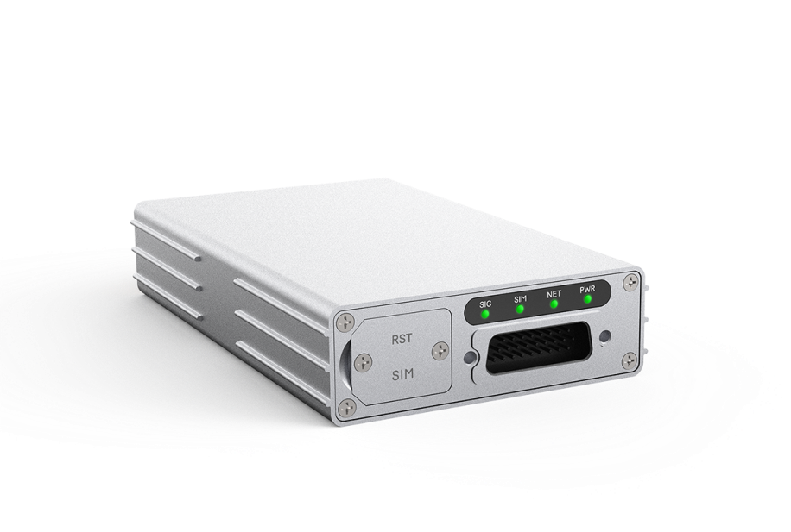5G Ruggedized Router

CAT20

5GNR/LTE/WCDMA

RS485

IP65

MDN80I Ruggedized Router from BTI is designed for industrial applications that converts 5G wireless signals into Gigabit Ethernet, providing stable and high-speed 5G access for the devices.

Designed for both indoor and outdoor harsh industrial environments, MDN80I meets high standards in vibration tolerance and is ideal for operations in robot, AGV, AMR, unmanned delivery cars, drones, logistics, automated manufacturing, port and other outdoor applications. MDN80I can also offer precise information about its real-time location; its built-in GNSS receiver allows GPS, GLONASS, Beidou and Galileo constellations.

|  |
| --- |
| **KEY FEATURES** |
| * Qualcomm SDX62 chipset solution * 5G NR and LTE-A CAT20 dual mode * Supports both SA and NSA * Global/CBRS bands supported * Ruggedized and anti-vibration design * Powerful software features * Web, TR069 and SNMP based device management * Supports 2.5G Ethernet port and RS485 industrial interface * IP65 rating for outdoor environment |

|  |
| --- |
| **SYSTEM ELEMENTS** |
|  |

|  |  |  |  |  |  |
| --- | --- | --- | --- | --- | --- |
| **HARDWARE SPECIFICATIONS** | | | | | |
| **Chipset** | Qualcomm SDX62 SoC | | | | |
| **Cellular Bands(MDN80I-A Europe & Asia version)** | 5G NR | | n1/n3/n5/n7/n8/n20/n28/n38/n40/n41/n75/n76/n77/n78 | | |
| LTE | | FDD B1/B3/B5/B7/B8/B20/B28/B32  TDD B38/B40/B41/B42/B43 | | |
| WCDMA | | B1/B5/B8 | | |
| **Cellular Bands(MDN80I-B North American version)** | 5G NR | | n2/n5/n7/n12/n13/n14/n25/n26/n29/n30/n38/n41/n48/n66/n70/n71/n77/n78 | | |
| LTE | | FDD B2/B4/B5/B7/B12/B13/B14/B25/B26/B29/B30/B66/B71  TDD B38/B41/B42/B43/B48  LAA B46 | | |
| **Category** | Rel-16/Sub6 5G & CAT20 | | | | |
| **GNSS** | GPS/GLONASS/BeiDou/Galileo | | | | |
| **Network Mode** | Supports SA/NSA | | | | |
| **External Port** | 1 x 2.5G Ethernet port  1 x RS485  1 x SIM Slot (4FF) | | | | |
| **LED** | 4 LED Indicators (PWR, NET, SIM, Tri-color SIG) | | | | |
| **Antenna Port** | 4 x LTE/NR Antenna  1 x GNSS | | | | |
| **Carrier Aggregation** | LTE: DL 5CA and UL 2CA  NR: 2CA | | | | |
| **MIMO(MDN80I-A**  **Europe & Asia version)** | Downlink | 5G NR:  4×4 MIMO on n1/n3/n5/n7/n8/n20/n28/n38/n40/n41/n75  n76/n77/n78  LTE:  4×4 MIMO on B1/B3/B5/B7/B8/B20/B28/B32/B38/B40/B41  B42/B43 | | | |
| Uplink | 5G NR: 2×2 MIMO on n38/n41/n77/n78 | | | |
| **MIMO (MDN80I-B**  **North American**  **version)** | Downlink | 5G NR:  4×4 MIMO on n2/n5/n7/n12/n13/n14/n25/n26/n29/n30/n38  n41/n48/n66/n70/n71/n77/n78  LTE:  4×4 MIMO on B2/B4/B5/B7/B12/B13/B14/B17/B25/B26/B29/B30/B38/B41/B42/B43/B48/B66/B71 | | | |
| Uplink | 5G NR: 2×2 MIMO on n38/n41/n48/n77/n78 | | | |
| **Maximum throughput** | Downlink | 5G NR SA (Gigabit Ethernet port) | | | 2.4Gbps |
| 5G NR NSA (Gigabit Ethernet port) | | | 2.5Gbps |
| 4G LTE (Gigabit Ethernet port) | | | 1.6Gbps |
| WCDMA (Gigabit Ethernet port) | | | 42Mbps |
| Uplink | 5G NR SA Sub 6 | | | 900Mbps |
| 5G NR NSA Sub 6 | | | 550Mbps |
| 4G LTE | | | 200Mbps |
| WCDMA | | | 5.76Mbps |
| **Maximum transmission power** | 5G NR Sub 6 bands | | | Class 3 (23 dBm ±2 dB) | |
| n41/n77/n78 HPUE | | | Class 2 (26 dBm +2/-3 dB) | |
| 4G LTE | | | Class 3 (23 dBm ±2 dB) | |
| B38/B41/B42 HPUE | | | Class 2 (26 dBm ±2 dB) | |
| WCDMA | | | Class 3 (24 dBm +1/-3 dB) | |
| **Power supply** | DC 8~24V, 12V default | | | | |
| **Power Consumption** | ＜24W | | | | |
| **GNSS** | Support GPS, GLONASS, Beidou and Galileo | | | | |
| **Dimensions** | 125mm x 75mm x 25mm | | | | |
| **Weight** | 420g | | | | |
| **Humidity** | Operation humidity: 5% - 95% (non-condensing)  Storage humidity: 5% - 95% (non-condensing) | | | | |
| **Temperature** | Operating temperature: -40 °C ~ +70 °C  Storage temperature: -40 °C ~ +85 °C | | | | |

|  |  |
| --- | --- |
| **SOFTWARE SPECIFICATIONS** | |
| **WAN** | Multi-APN support, maximum four |
| IP pass-through |
| IPv4/v6 dual stack |
| **LAN** | IEEE 802.1Q VLAN |
| DHCP Server |
| DNS and DNS proxy |
| DMZ |
| Multi-cast/ Multi-cast proxy |
| **Protocol** | Routing: Static routing |
| **Device management** | TR069 |
| SNMP v2 |
| WebGUI |
| Software upgrade via Web UI/TR069/FOTA |
| USIM PIN management |
| **Routing Mode** | Route mode |
| Bridge mode |
| NAT mode |
| Static Route |
| Port Mirror and Port Forwarding |
| IPV4/IPV6 dual stack |
| **VPN** | PPTP |
| GRE tunnel |
| L2TP V2/V3 |
| **Security** | Firewall |
| Mac address filtering |
| IP address filtering |
| URL filtering |
| Access control |
| HTTPS login from WAN |
| DOS attack protection |
| Two level of user authority |

|  |  |
| --- | --- |
| **COMPLIANCE SPECIFICATIONS** | |
| **Environment Compliance** | Protection rating: IP65 |
| Shockproof: ISO 16750-3 : 2012 ( E） |

Contact Us

[www.btiwireless.com](http://www.btiwireless.com)

[sales@btiwireless.com](mailto:sales@btiwireless.com)