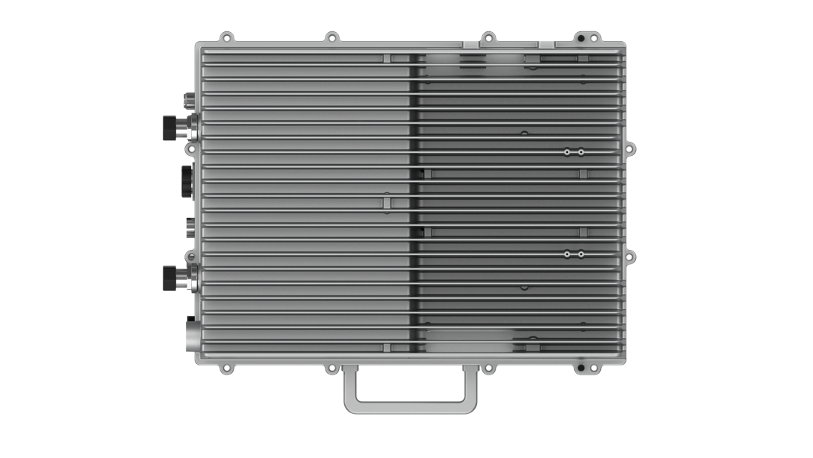
sCELL-H2000
LTE Integrated eNodeB

2*20W with MIMO
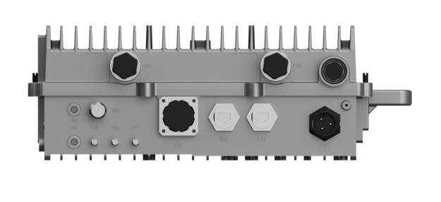
Passive Cooling IP65
192 Concurrent Users
384 RRC Users

The sCELL-H2000 from BTI WIRELESS is an advanced outdoor LTE compact product that operates in TDD mode. This eNB provides users with high-speed broadband wireless access to the Internet using 2x20W output power (2x2 MIMO with 20W output each channel). This eNodeB can operate in 5, 10, 15 or 20 MHz bandwidth, supporting 192 concurrent users and 384 RRC users.

KEY FEATURES
- Standard LTE TDD Band 40/Band 38 or customized
- Complies with 3GPP Release 13 standard
- Supports 5/10/15/20 MHz bandwidth
- GUI-based local and remote Web management
- TR069 network management interface support
- External high-gain antenna
- Peak rate (per unit):
SA1 DL: 80 Mbps, UL: 20 Mbps @ 20 MHz bandwidth
SA2 DL: 110 Mbps, UL: 10 Mbps @ 20 MHz bandwidth
- 192 concurrent users per eNodeB
- 384 RRC users per eNodeB
- Passive Cooling IP65

HARDWARE SPECIFICATIONS
LTE Mode | TDD
Frequency Bands | B38/B40 or customized
Channel Bandwidth | 5/10/15/20 MHz
Max Output Power | 43dBm / channel
Power Supply | -48V DC or 220V AC
Power Consumption | ≤ 250W
Receive Sensitivity | < -104dBm
Synchronization | GPS, 1588 (optional)
Interfaces | One optical (SFP) and one RJ-45 Ethernet interface
MIMO | 2 x 2
Installation | Pole or wall mount
Antenna Type | External high-gain antenna compatible with eNodeB 4.3-10 Female interface
Dimensions (HxWxD) | 400 x 300 x 125 mm | 15.75 x 11.81 x 4.92 in
Weight | < 20 kg | 44.1 lbs (exclude accessories)
MTBF | > 100,000 hours

SOFTWARE SPECIFICATIONS
LTE Standard | 3GPP Release 13
User Capacity | 192 concurrent users  384 RRC users
QoS Control | 3GPP standard GBR QCI (1-4), Non GBR QCI (5-9)
Modulation | DL: QPSK, 16QAM, 64QAM, 256QAM  UL: QPSK, 16QAM, 64QAM
Network Management | TR069
Maintenance | Remote or local maintenance  Online status management  Performance statistics  Fault management  Local or remote software upgrade  Logging  Connectivity diagnosis  Automatic start and configuration  Alarm reporting  User information tracing  Signaling trace

INTERFACE
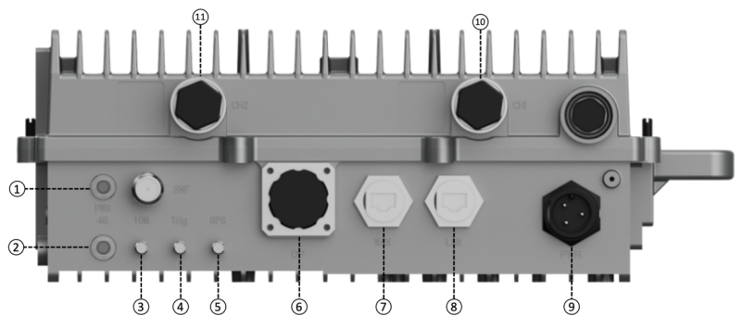

INTERFACE SPECIFICATIONS
1 | PWR light | Power-on indicator light
2 | 4G light | Active cell indicator light
3 | 10M | 10M input interface (for testing)
4 | Trig | Trig signal output port (for testing)
5 | GPS | SNIFF interface for GPS synchronization
6 | OP | Optical port backhaul interface
7 | WAN | Backhaul network port, connected to the core network
8 | LAN | Local commissioning network port, used to log in to the local web or telnet
9 | PWR | Power supply interface
10 | CH1 | LTE RF output port 1
11 | CH2 | LTE RF output port 2

ENVIRONMENTAL SPECIFICATIONS
Operating Temperature | -40 °C ~ +55 °C | -40 °F ~ +131 °F
Storage Temperature | -40 °C ~ +75 °C | -40 °F ~ +158 °F
Humidity | 5% ~ 98%
Atmospheric Pressure | 86 KPa ~ 106 KPa
Ingress Protection Rating | IP65
Lightning Protection | GB/T 17626.5 standard
Note: Features may vary based on model or region.

TYPICAL APPLICATION
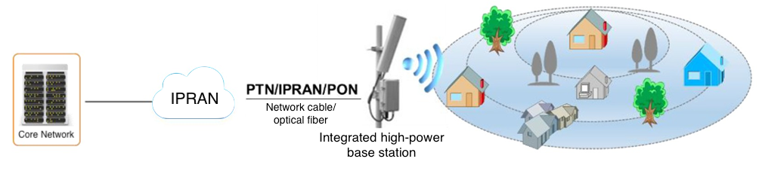
In rural and suburban areas, the wireless network coverage is relatively wide, but the users are less fixed than the fixed ones. By deploying LTE integrated high-power base stations in a town or natural village, the signal coverage in a small area can be achieved, reaching low Investment in rural 4G wireless access.

In order to solve the indoor and outdoor coverage problems of large and medium-sized scenes in Hunan Province, Hunan Mobile purchases our integrated high-power base stations to increase the breadth and depth of network coverage, which greatly improves network quality and service quality.
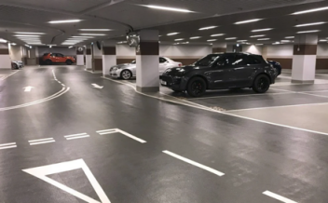
Rural Road Industrial Campus Capacity Compensation

Contact Us
www.btiwireless.com
sales@btiwireless.com

