
CP880
LTE Outdoor CPE

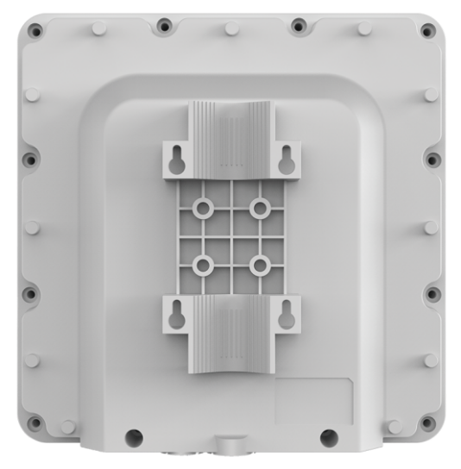
3GPP Release 12
CAT12
All LTE Bands
PoE
IP67

The CP880 from BTI WIRELESS is a premium outdoor LTE CPE. The product provides a high throughput data transmission network for residential, commercial and enterprise users. Customers enjoy an easy plug & play broadband access solution and large area coverage for various network service scenarios.

RF SPECIFICATIONS
Supports Bands* | Option 1 | B1/3/7/8/(17)/20/(28)/38/(40)/41/42/43/48
Supports Bands* | Option 2 (Prototype) | B2/4/5/8/12/14/17/25/26/38/41/42/43/48/66
Supports Bands* | Option 3 | B42/43/48
Supports Bands* | Option 4 | B7/38/41
Peak Throughput | TDD DL 560Mbps; UL 30Mbps (Config 2:7)  FDD DL 800Mbps; UL 150Mbps
Carrier Aggregation (CA) | DL Inter/Intra 2CA/3CA/4CA  UL Inter/Intra 2CA
MIMO | DL 2 x 2 (4 CA 256 QAM)  DL 4 x 4 (2 CA 64 QAM)  UL 2 x 2 64 QAM
Tx / Rx | 2 Tx / 4 Rx
Output Power @ 25 ℃ | 77 ℉ | Max 23 ± 2dBm, configurable
Receiving Sensitivity | FDD | -100dBm/ 10 MHz @ QPSK
Receiving Sensitivity | TDD | -97dBm/ 20 MHz @ QPSK
LTE Antenna | 4 directional antennas
LTE Antenna Gain | Option 1 | 700 MHz ~ 1 GHz: 6 dBi  1.7 GHz ~ 2.1 GHz: 7 dBi  2.3 GHz ~ 2.7 GHz: 9 dBi  3.4 GHz ~ 3.8 GHz: 8 dBi
LTE Antenna Gain | Option 2 | 700 MHz ~ 1 GHz: 6 dBi  1.7 GHz ~ 2.1 GHz: 7 dBi  2.3 GHz ~ 2.7 GHz: 9 dBi  3.4 GHz ~ 3.8 GHz: 8 dBi
LTE Antenna Gain | Option 3 | 3.4 GHz ~ 3.8 GHz: 16 dBi
LTE Antenna Gain | Option 4 | 2.5 GHz ~ 2.7 GHz: 13 dBi
*The frequency bands in () are not included in the conventional sample.

HARDWARE SPECIFICATIONS
LTE Standard | 3GPP Release 12, CAT 12
Flash | 2 GB
DDR | 2 GB
Power Supply | 24V Non-standard PoE default  IEEE 802.3 at compatible PoE customized
Ethernet LAN Port/POE Input | 1 x RJ45 10/100/1000Mb/s
Water and Dust proof | IP67
LED | 4 LED Indicators (PWR, NET, SIM, RF Signal)
SIM | 1 x SIM Slot (1.8V/3.0V 2FF)
Reset | Pin Hole
Antenna | 4 Built-in directional antennas
Dimensions | 288 x 288 x 82 mm | 11.3 x 11.3 x 3.2 in
Weight | ODU < 2 kg | 4.41 lbs
Power Consumption | < 8W
Power Adapter | Input: AC 90 ~ 240V  Output: DC 24V/ 0.5A

ENVIRONMENT SPECIFICATIONS
Temperature | Operating | -40 ℃ ~ +55 ℃ | -40 °F ~ +131 °F
Temperature | Storage | -40 ℃ ~ +85 ℃ | -40 °F ~ +185 °F
Humidity | Operating | 5 ~ 95%
Humidity | Storage | 5 ~ 95%

TOPOLOGY
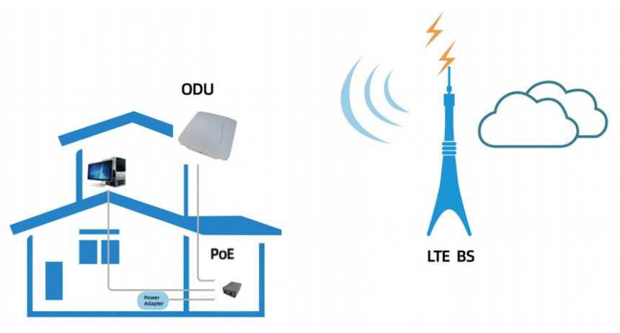

SOFTWARE SPECIFICATIONS
Operation Mode | NAT mode
Operation Mode | Route Mode
Operation Mode | Bridge Mode
Device Management | TR069
Device Management | SNMP
Device Management | WebUI
Device Management | Software Upgrade - FOTA
Network Protocols and Features | Multi-APN
Network Protocols and Features | NAT/NATP
Network Protocols and Features | SNTP/NITZ  Static Routing
Network Protocols and Features | Virtual server and DMZ
Network Protocols and Features | DNS relay and DDNS
Network Protocols and Features | IGMP snooping and IGMP proxy
Network Protocols and Features | DHCP server
Network Protocols and Features | IPV4/IPv6 Dual Stack
Network Protocols and Features | UPnP
Network Protocols and Features | Parents control
VPN | IPSec
VPN | PPTP
VPN | L2TP V2/V3
VPN | GRE L2/L3
VPN | L2TP over IPsec
VPN | GRE over IPsec
Security and Firewall | MAC Address Filtering
Security and Firewall | IP Address Filtering
Security and Firewall | URL Filtering
Security and Firewall | DDOS

Contact Us
www.btiwireless.com
sales@btiwireless.com

