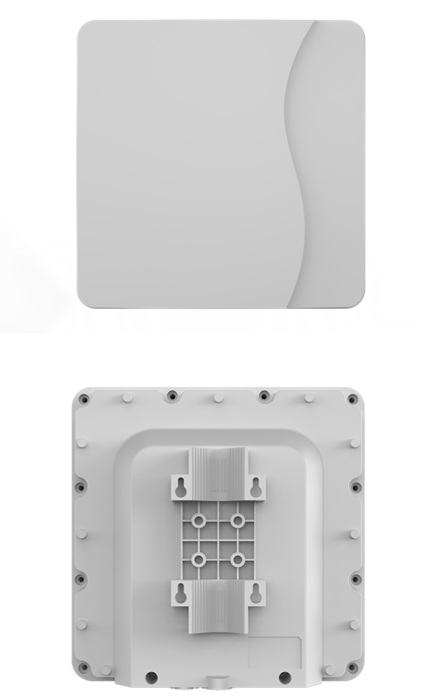

CP680

LTE Outdoor CPE

3GPP Release 10/11

CAT6

All LTE Bands

PoE

IP67

The CP680 from BTI WIRELESS is a high-performance outdoor LTE CPE. The product provides a high throughput data transmission network for residential, commercial and enterprise users. Customers enjoy an easy plug & play broadband access solution and large area coverage for various network service scenarios.

|  |  |  |
| --- | --- | --- |
| **CELLULAR SPECIFICATIONS** | | |
| **LTE Standard** | 3GPP Release 10/ 11, CAT 6 | |
| **Peak Throughput** | FDD DL 300Mbps; UL 75Mbps | |
| TDD DL 220Mbps; UL 15Mbps (Config 2:7) | |
| **LTE Bands\*** | Option 1 | B1/3/7/8/(17)/20/(28)/38/(40)/41/42/43/48 |
| Option 2 (Prototype) | B2/4/5/8/12/14/17/25/26/38/41/42/43/48/66 |
| Option 3 | B42/43/48 |
| Option 4 | B7/38/41 |
| **Carrier Aggregation (CA) and MIMO** | CA: DL Intra/Inter 2CA | |
| MIMO: DL 2 x 2 MIMO/ 4 X 4 MIMO | |
| **Tx / Rx** | 1Tx / 4Rx | |
| **Transmit Power** | Power Class 3 (23 ± 2dBm) | |
| **LTE Antenna** | 4 directional antennas | |
| **LTE Antenna Gain** | Option 1 | 700 MHz ~ 1 GHz: 6 dBi  1.7 GHz ~ 2.1 GHz: 7 dBi  2.3 GHz ~ 2.7 GHz: 9 dBi  3.4 GHz ~ 3.8 GHz: 8 dBi |
| Option 2 | 700 MHz ~ 1 GHz: 6 dBi  1.7 GHz ~ 2.1 GHz: 7 dBi  2.3 GHz ~ 2.7 GHz: 9 dBi  3.4 GHz ~ 3.8 GHz: 8 dBi |
| Option 3 | 3.4 GHz ~ 3.8 GHz: 15 dBi |
| Option 4 | 2.5 GHz ~ 2.7 GHz: 13 dBi |

*\*The frequency bands in () are not included in the conventional sample.*

|  |
| --- |
| **TOPOLOGY** |
|  |

|  |  |
| --- | --- |
| **HARDWARE SPECIFICATIONS** | |
| **Fixed Interfaces** | 1 x RJ45 10/ 100/ 1000Mb/s |
| 1 x SIM slot (1.8V/ 3.0V 2FF) |
| **LED Indicator** | 4 LED indicators (PWR, NET, SIM, RF signal) |
| **Reset** | Pin Hole |
| **Power Supply** | 24V non-standard POE default |
| IEEE 802.3at compatible POE customized |
| **Power Consumption** | < 8W |
| **Power Adapter** | Input: AC 90 ~ 240V |
| Output: DC 24V/ 0.5A |
| **Water and Dustproof** | IP67 |
| **Dimensions and Mounting** | Dimensions: 288 x 288 x 82 mm | 11.3 x 11.3 x 3.2 in |
| Weight: < 2 kg | 4 lbs |
| Mounting: rail and wall mounting |
| **Temperature and Humidity** | Operating: -40 ℃ ~ +55 ℃ | -40 °F ~ +131 °F |
| Storage: -40 ℃ ~ +85 ℃ | -40 °F ~ +185 °F |
| Humidity: 5% ~ 95% |

|  |  |
| --- | --- |
| **SOFTWARE SPECIFICATIONS** | |
| **Operation Mode** | NAT mode |
| Route Mode |
| Bridge Mode |
| **Device Management** | TR069 |
| SNMP |
| Web UI |
| Software upgrade- FOTA |
| USIM PIN management |
| **Network Protocols**  **and Features** | Multi-APN |
| NAT/NATP |
| SNTP/NITZ |
| Static Routing |
| Virtual server and DMZ |
| DNS relay and DDNS |
| IGMP snooping and IGMP proxy |
| DHCP server |
| IPV4/IPv6 Dual Stack |
| UPnP |
| Parents control |
| **VPN** | IPsec |
| PPTP |
| GRE (L2/L3) |
| L2TP v2/v3 |
| GRE over IPsec |
| L2TP over IPsec |
| **Security and Firewall** | MAC address filtering |
| IP address filtering |
| URL filtering |
| DDOS |

Contact Us

[www.btiwireless.com](http://www.btiwireless.com)

[sales@btiwireless.com](mailto:sales@btiwireless.com)